Introduction to RESTful Web Services
REST stands for REpresentational State Transfer. It is developed by Roy Thomas Fielding, who also developed HTTP. The main goal of RESTful web services is to make web services more effective. RESTful web services try to define services using the different concepts that are already present in HTTP. REST is an architectural approach, not a protocol.
It does not define the standard message exchange format. We can build REST services with both XML and JSON. JSON is more popular format with REST. The key abstraction is a resource in REST. A resource can be anything. It can be accessed through a Uniform Resource Identifier (URI). For example:
The resource has representations like XML, HTML, and JSON. The current state capture by representational resource. When we request a resource, we provide the representation of the resource. The important methods of HTTP are:
- GET: It reads a resource.
- PUT: It updates an existing resource.
- POST: It creates a new resource.
- DELETE: It deletes the resource.
For example, if we want to perform the following actions in the social media application, we get the corresponding results.
POST /users: It creates a user.
GET /users/{id}: It retrieves the detail of a user.
GET /users: It retrieves the detail of all users.
DELETE /users: It deletes all users.
DELETE /users/{id}: It deletes a user.
GET /users/{id}/posts/post_id: It retrieve the detail of a specific post.
POST / users/{id}/ posts: It creates a post of the user.
Further, we will implement these URI in our project.
HTTP also defines the following standard status code:
- 404: RESOURCE NOT FOUND
- 200: SUCCESS
- 201: CREATED
- 401: UNAUTHORIZED
- 500: SERVER ERROR

RESTful Service Constraints
- There must be a service producer and service consumer.
- The service is stateless.
- The service result must be cacheable.
- The interface is uniform and exposing resources.
- The service should assume a layered architecture.

Advantages of RESTful web services
- RESTful web services are platform-independent.
- It can be written in any programming language and can be executed on any platform.
- It provides different data format like JSON, text, HTML, and XML.
- It is fast in comparison to SOAP because there is no strict specification like SOAP.
- These are reusable.
- They are language neutral.

Initializing a RESTful Web Services Project with Spring Boot
Step 1: Download the Spring Tool Suite (STS) from https://spring.io/tools3/sts/all and extract it.
Step 2: Launch the STS.
Step 3: Click on File menu -> New -> Spring Starter Project ->
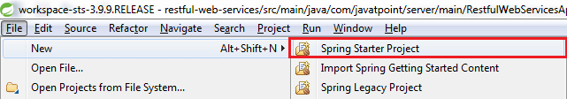
If the Spring Starter Project is not enlisted, then click on Other at the bottom of the menu. A dialog box appears on the screen. Type Spring Starter Project in the Wizards text box and click on the Next button.
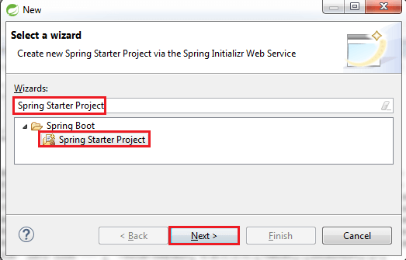
Step 4: provide the name, group, and package of the project. We have provided:
Name: restful-web-services
Group: com.javatpoint
Package: com.javatpoint.server.main
Click on the Next button.
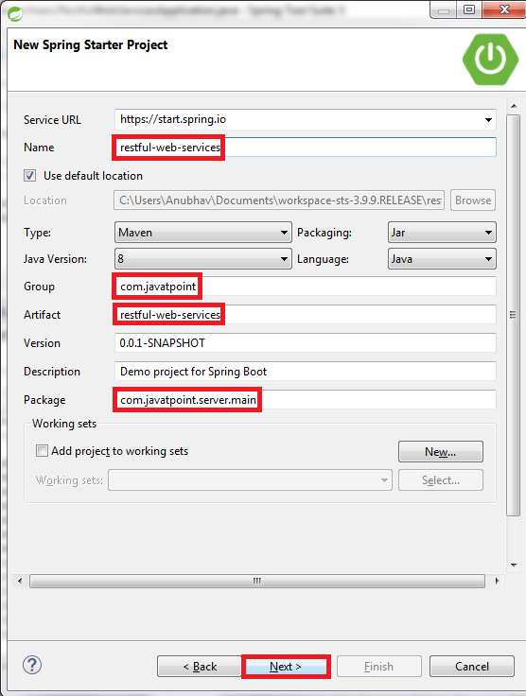
Step 5: Choose the Spring Boot Version 2.1.8.
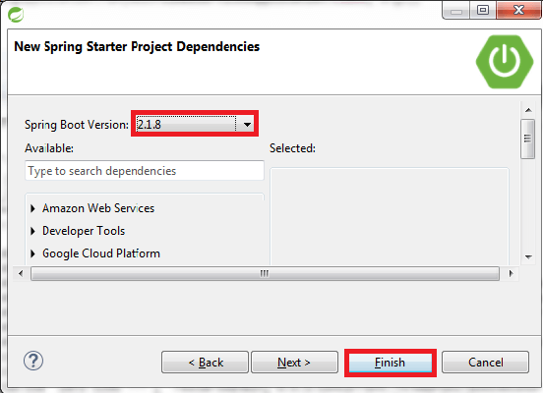
Step 6: We can see the project structure in the project explorer window.
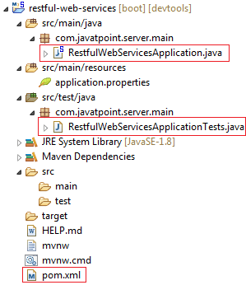
Step 7: Go to the Maven Repository https://mvnrepository.com/ and add Spring Web MVC, Spring Boot DevTools, JPA, and H2 dependencies in the pom.xml. After adding the dependencies, the pom.xml file looks like the following:
pom.xml
- <project xmlns="http://maven.apache.org/POM/4.0.0"
- xmlns:xsi="http://www.w3.org/2001/XMLSchema-instance"
- xsi:schemaLocation="http://maven.apache.org/POM/4.0.0
- http://maven.apache.org/xsd/maven-4.0.0.xsd">
- <modelVersion>4.0.0</modelVersion>
- <parent>
- <groupId>org.springframework.boot</groupId>
- <artifactId>spring-boot-starter-parent</artifactId>
- <version>2.1.8.RELEASE</version>
- <relativePath/> <!-- lookup parent from repository -->
- </parent>
- <groupId>com.javatpoint</groupId>
- <artifactId>restful-web-services</artifactId>
- <version>0.0.1-SNAPSHOT</version>
- <name>restful-web-services</name>
- <description>Demo project for Spring Boot</description>
- <properties>
- <java.version>1.8</java.version>
- </properties>
- <dependencies>
- <dependency>
- <groupId>org.springframework.boot</groupId>
- <artifactId>spring-boot-starter</artifactId>
- </dependency>
- <dependency>
- <groupId>org.springframework.boot</groupId>
- <artifactId>spring-boot-starter-activemq</artifactId>
- </dependency>
- <dependency>
- <groupId>org.springframework.boot</groupId>
- <artifactId>spring-boot-starter-web</artifactId>
- </dependency>
- <dependency>
- <groupId>org.springframework.boot</groupId>
- <artifactId>spring-boot-starter-tomcat</artifactId>
- </dependency>
- <dependency>
- <groupId>org.springframework</groupId>
- <artifactId>spring-webmvc</artifactId>
- </dependency>
- <!-- https://mvnrepository.com/artifact/org.springframework.boot/spring-boot-devtools -->
- <dependency>
- <groupId>org.springframework.boot</groupId>
- <artifactId>spring-boot-devtools</artifactId>
- <scope>runtime</scope>
- </dependency>
- <!-- https://mvnrepository.com/artifact/org.hibernate.javax.persistence/hibernate-jpa-2.1-api -->
- <dependency>
- <groupId>org.hibernate.javax.persistence</groupId>
- <artifactId>hibernate-jpa-2.1-api</artifactId>
- <version>1.0.0.Final</version>
- </dependency>
- <!-- https://mvnrepository.com/artifact/com.h2database/h2 -->
- <dependency>
- <groupId>com.h2database</groupId>
- <artifactId>h2</artifactId>
- <scope>runtime</scope>
- </dependency>
- <dependency>
- <groupId>org.apache.maven</groupId>
- <artifactId>maven-archiver</artifactId>
- <version>2.5</version>
- </dependency>
- <dependency>
- <groupId>org.springframework.boot</groupId>
- <artifactId>spring-boot-starter-test</artifactId>
- <scope>test</scope>
- </dependency>
- </dependencies>
- <build>
- <plugins>
- <plugin>
- <groupId>org.springframework.boot</groupId>
- <artifactId>spring-boot-maven-plugin</artifactId>
- </plugin>
- </plugins>
- </build>
- </project>
Step 8: Now open the RestfulWebServicesApplication.java file and Run the file as Java Application.
- package com.javatpoint.server.main;
- import org.springframework.boot.SpringApplication;
- import org.springframework.boot.autoconfigure.SpringBootApplication;
- @SpringBootApplication
- public class RestfulWebServicesApplication
- {
- public static void main(String[] args)
- {
- SpringApplication.run(RestfulWebServicesApplication.class, args);
- }
- }
It does not perform any service but ensures that the application is running properly.

Output

Creating a Hello World Service
Step 1: Create a new class with the name HelloWorldController in the package com.javatpoint.server.main.
Step 2: Whenever we create a web service, we need to define two things Get method and the URI. Now create the helloWorld() method which returns the string "Hello World." If we want to tell the spring MVC that it is going to handle the REST request, we have to add @RestController annotation. Now it becomes a rest controller which can handle the Rest request.
The next thing we have to do is create a mapping for the method. Add @RequestMapping annotation just above the helloWorld() method. The HelloWorldController looks like the following:
- package com.javatpoint.server.main;
- import org.springframework.web.bind.annotation.RequestMapping;
- import org.springframework.web.bind.annotation.RequestMethod;
- import org.springframework.web.bind.annotation.RestController;
- //Controller
- @RestController
- public class HelloWorldController
- {
- //using get method and hello-world as URI
- @RequestMapping(method=RequestMethod.GET, path="/hello-world")
- public String helloWorld()
- {
- return "Hello World";
- }
- }
We can also improve the above code by using the @GetMapping annotation instead of @RequestMapping. Here the method specification is not required.
- package com.javatpoint.server.main;
- import org.springframework.web.bind.annotation.GetMapping;
- import org.springframework.web.bind.annotation.RestController;
- //Controller
- @RestController
- public class HelloWorldController
- {
- //using get method and hello-world as URI
- @GetMapping(path="/hello-world")
- public String helloWorld()
- {
- return "Hello World";
- }
- }
Step 3: Run the RestfulWebServiceApplication. It displays the string Hello World on the browser.

Enhancing the Hello World Service to Return a Bean
In this section, we are going to generate a bean for the method helloWorld().
Step 1: Create a helloWorldBean() method in HelloWordController.java file. Map the URI to "/hello-world-bean" and return HelloWorldBean.
HelloWorldController.java
- package com.javatpoint.server.main;
- import org.springframework.web.bind.annotation.GetMapping;
- import org.springframework.web.bind.annotation.RestController;
- //Controller
- @RestController
- public class HelloWorldController
- {
- //using get method and hello-world URI
- @GetMapping(path="/hello-world")
- public String helloWorld()
- {
- return "Hello World";
- }
- @GetMapping(path="/hello-world-bean")
- public HelloWorldBean helloWorldBean()
- {
- return new HelloWorldBean("Hello World"); //constructor of HelloWorldBean
- }
- }
Step 2: Create a class HelloWorldBean.
Step 3: Generate Getters and Setters.
Right-click -> Source -> Generate Getters and Setters -> check the box -> Ok
Step 4: Generate toString()..
Right-click -> Source -> Generate toString().. -> Ok
HelloWorldBean.java
- package com.javatpoint.server.main;
- public class HelloWorldBean
- {
- public String message;
- //constructor of HelloWorldBean
- public HelloWorldBean(String message)
- {
- this.message=message;
- }
- //generating getters and setters
- public String getMessage()
- {
- return message;
- }
- public void setMessage(String message)
- {
- this.message = message;
- }
- @Override
- //generate toString
- public String toString()
- {
- return String.format ("HelloWorldBean [message=%s]", message);
- }
- }
Step 5: Launch the HelloWorldController. The URL of the browser changes to localhost:8080/hello-world-bean.
It returns the message "Hello World" in JSON format.
- {
- message: "Hello World"
- }

Spring Boot Auto Configuration and Dispatcher Servlet
In this section, we will see the background functionality of the application:
What is dispatcher servlet?
Who is configuring dispatcher servlet?
What does dispatcher servlet do?
How does the HelloWorldBean object gets converted to JSON?
Who is configuring the error mapping?

Spring Boot Auto Configuration
- Spring Boot automatically configures a spring application based on dependencies present or not present in the classpath as a jar, beans, properties, etc.
- It makes development easier and faster as there is no need to define certain beans that are included in the auto-configuration classes.
- A typical MVC database driven Spring MVC application requires a lot of configuration such as dispatcher servlet, a view resolver, Jackson, data source, transaction manager, among many others.
  - Spring Boot auto-configures a Dispatcher Servlet if Spring MVC jar is on the classpath.
  - Auto-configures the Jackson if Jackson jar is on the classpath.
  - Auto-configures a Data Source if Hibernate jar is on the classpath.
- Auto-configuration can be enabled by adding @SpringBootApplication or
@EnableAutoConfiguration annotation in startup class. It indicates that it is a spring context file.
- It enables something called auto-configuration.
- It enable something called components scan. It is the features of Spring where it will start automatically scanning classes in the package and sub package for any bean file.
- There is some example of auto configuration done by Spring Boot:
  - DispatcherServletAutoConfiguration
  - DataSourceAutoConfiguration
  - JacksonAutoConfiguration
  - ErrorMvcAutoConfiguration (#basicErrorController)
- We can see the auto-configuration done by Spring Boot in the AUTO-CONFIGURATION REPORT or CONDITIONS EVALUATION REPORT.
- Classes can be excluded from auto-configuration by adding:
- @SpringBootApplication (exclude={JacksonAutoConfiguration.class, JmxAutoConfiguration.class})
Or add the following statement in the application.properties file.
- spring.autoconfiguration.exclude=org.springframework.boot.autoconfigure.jackson.JacksonAutoConfiguration
We exclude classes form the auto-configuration for faster startup and better performance of the application.
- AUTO-CONFIGURATION REPORT generated by enabling debug mode. Open the application.properties file and add the following statement:
- logging.level.org.springframework=debug
Run RestfulWebServiceApplication.java file. It shows the Positive matches, Negative matches, Exclusions, and Unconditional classes under the CONDITIONS EVALUATION REPORT.
- -----------------------------------------------
- CONDITIONS EVALUATION REPORT
- -----------------------------------------------
- Positive matches:
- ----------------------
- ActiveMQAutoConfiguration matched:
- - @ConditionalOnClass found required classes 'javax.jms.ConnectionFactory', 'org.apache.activemq.ActiveMQConnectionFactory' (OnClassCondition)
- - @ConditionalOnMissingBean (types: javax.jms.ConnectionFactory; SearchStrategy: all) did not find any beans (OnBeanCondition)
- ------------------
- ------------------
- ------------------
- Negative matches:
- -------------------------
- ActiveMQConnectionFactoryConfiguration.PooledConnectionFactoryConfiguration: Did not match:
- -@ConditionalOnClass did not find required classes 'org.messaginghub.pooled.jms.JmsPoolConnectionFactory','org.apache.commons.pool2.PooledObject' (OnClassCondition)
- ----------------
- ----------------
- ----------------
- Exclusions:
- ---------------
- None
- Unconditional classes:
- ----------------------------- org.springframework.boot.autoconfigure.context.ConfigurationPropertiesAutoConfiguration
- org.springframework.boot.autoconfigure.context.PropertyPlaceholderAutoConfiguration
There is a lot of information inside the report, so it is not possible to show all the detail. If we scroll down the report and have a closure look at auto configuration log, we found DispatcherServletAutoConfiguration matched.
- DispatcherServletAutoConfiguration matched:
- -@ConditionalOnClass found required class 'org.springframework.web.servlet.DispatcherServlet' (OnClassCondition)
- - found 'session' scope (OnWebApplicationCondition)
It is because, the dependency spring-boot-starter-web depends on spring-webmvc dependency. Therefore we get the DispatcherServlet class in our classpath.

Dispatcher Servlet
In Spring MVC all incoming requests go through a single servlet is called Dispatcher Servlet (front controller). The front controller is a design pattern in web application development. A single servlet receives all the request and transfers them to all other components of the application.
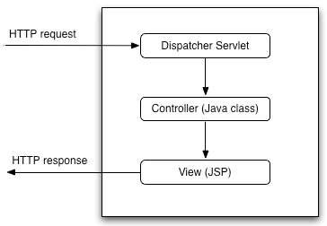
The job of DispatcherServlet is to take an incoming URI and find the right combination of handlers (Controller classes) and views (usually JSPs). When the DispatcherServlet determines the view, it renders it as the response. Finally, the DispatcherServlet returns the Response Object to back to the client. In short, the Dispatcher Servlet plays the key role.
The other thing to notice is that ErrorMvcAutoConfiguration:
- ErrorMvcAutoConfiguration matched:
- -@ConditionalOnClass found required classes 'javax.servlet.Servlet', 'org.springframework.web.servlet.DispatcherServlet' (OnClassCondition)- found 'session' scope (OnWebApplicatiossssnCondition)
It configures the basicErrorController, errorAttributes, ErrorMvcAutoConfiguration, and DefaultErrorViewResolverConfiguration. It creates the default error page which is known as Whitelabel Error Page.
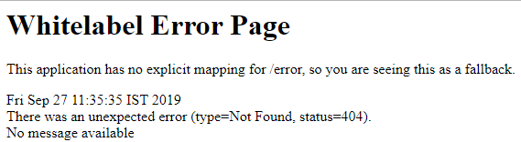
The other thing which is auto-configured HttpMessageConvertersAutoConfiguration. These message converter automatically converts the message.
- HttpMessageConvertersAutoConfiguration matched:
- -@ConditionalOnClass found required class 'org.springframework.http.converter.HttpMessageConverter' (OnClassCondition)
- ----------------
- -----------------
- JacksonAutoConfiguration.Jackson2ObjectMapperBuilderCustomizerConfiguration matched: - @ConditionalOnClass found required class 'org.springframework.http.converter.json.Jackson2ObjectMapperBuilder'(OnClassCondition)
It initializes the Jackson bean and the message converter. The Jackson2ObjectMapper does the conversion from bean to JSON and JSON to bean.

Enhancing the Hello World Service with a Path Variable
The @PathVariable annotation is used to extract the value from the URI. It is most suitable for the RESTful web service where the URL contains some value. Spring MVC allows us to use multiple @PathVariable annotations in the same method. A path variable is a critical part of creating rest resources.
We will create another hello-world-bean request with a path parameter.
Step 1: Open the HelloWorldController.java file and add another helloWorldBean() service.
HelloWorldController.java
- package com.javatpoint.server.main;
- import org.springframework.web.bind.annotation.GetMapping;
- import org.springframework.web.bind.annotation.PathVariable;
- import org.springframework.web.bind.annotation.RestController;
- import org.springframework.context.annotation.Configuration;
- @Configuration
- //Controller
- @RestController
- public class HelloWorldController
- {
- //using get method and hello-world URI
- @GetMapping(path="/hello-world")
- public String helloWorld()
- {
- return "Hello World";
- }
- @GetMapping(path="/hello-world-bean")
- //method- which returns "Hello World"
- public HelloWorldBean helloWorldBean()
- {
- return new HelloWorldBean("Hello World");//constructor of HelloWorldBean
- }
- //passing a path variable
- @GetMapping(path="/hello-world/path-variable/{name}")
- public HelloWorldBean helloWorldPathVariable(@PathVariable String name)
- {
- return new HelloWorldBean(String.format("Hello World, %s", name)); //%s replace the name
- }
- }
Whatever value we will pass to the path variable is picked up by the controller and returned to the response.
Step 2: Type the URL http://localhost:8080///hello-world/path-variable/javatpoint
Step 3: Run the HelloWorldController.java file. We get the following response on the browser.
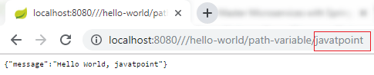
Let's change the path variable once again: http://localhost:8080/hello-world/path-variable/Anubhav
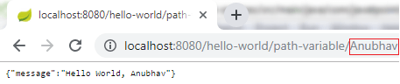
We can see that whatever we are writing in the path variable is returned to the response.

Creating User Bean and User Service
In this section, we are going to create real resources users and the post. We will use a static array list to represent the data.
Step 1: Create a new package with the name com.javatpoint.server.main.user.
Step 2: Create a bean class (User) to store the user detail.
Right click on the package user -> New -> Class -> Provide Name -> Finish. Here, we have provided class name User.
Step 3: Define three private variables id, name, and dob.
Step 4: Generate Getters and Setters.
Right click on the file -> Source -> Generate Getters and Setters... ->Select All -> Generate.
Step 5: Generate toString.
Right click on the file -> Source -> Generate toString... ->Select All -> Generate.
Step 6: Generate Constructors.
Right click on the file -> Source -> Generate Constructor using Fields... -> Generate.
User.java
- package com.javatpoint.server.main.user;
- import java.util.Date;
- public class User
- {
- public User(Integer id, String name, Date dob)
- {
- super();
- this.id = id;
- this.name = name;
- this.dob = dob;
- }
- private Integer id;
- private String name;
- private Date dob;
- public Integer getId()
- {
- return id;
- }
- public void setId(Integer id)
- {
- this.id = id;
- }
- public String getName()
- {
- return name;
- }
- public void setName(String name)
- {
- this.name = name;
- }
- public Date getDob()
- {
- return dob;
- }
- public void setDob(Date dob)
- {
- this.dob = dob;
- }
- @Override
- public String toString()
- {
- //return "User [id=" + id + ", name=" + name + ", dob=" + dob + "]";
- return String.format("User [id=%s, name=%s, dob=%s]", id, name, dob);
- }
- }
Before moving to the next step first move HelloWorldBean.java and HelloWorldController.java in the package com.javatpoint.server.main.helloworld.
Step 7: Create a class with name UserDaoService in the package com.javatpoint.server.main.user.
UserDaoService.java
- package com.javatpoint.server.main.user;
- import java.util.ArrayList;
- import java.util.Date;
- import java.util.List;
- import org.springframework.stereotype.Component;
- @Component
- public class UserDaoService
- {
- public static int usersCount=5;
- //creating an instance of ArrayList
- private static List<User> users=new ArrayList<>();
- //static block
- static
- {
- //adding users to the list
- users.add(new User(1, "John", new Date()));
- users.add(new User(2, "Robert", new Date()));
- users.add(new User(3, "Adam", new Date()));
- users.add(new User(4, "Andrew", new Date()));
- users.add(new User(5, "Jack", new Date()));
- }
- //method that retrieve all users from the list
- public List<User> findAll()
- {
- return users;
- }
- //method that add the user in the list
- public User save(User user)
- {
- if(user.getId()==null)
- {
- //increments the user id
- user.setId(++usersCount);
- }
- users.add(user);
- return user;
- }
- //method that find a particular user from the list
- public User findOne(int id)
- {
- for(User user:users)
- {
- if(user.getId()==id)
- return user;
- }
- return null;
- }
- }

Implementing Get Methods for User Resource
Step 8: Now create a user controller class with name UserResource.
UserResource.java
- package com.javatpoint.server.main.user;
- import java.util.List;
- import org.springframework.beans.factory.annotation.Autowired;
- import org.springframework.web.bind.annotation.GetMapping;
- import org.springframework.web.bind.annotation.RestController;
- @RestController
- public class UserResource
- {
- @Autowired
- private UserDaoService service;
- @GetMapping("/users")
- public List<User> retriveAllUsers()
- {
- return service.findAll();
- }
- }
Step 9: Run the application and type the localhost:8080/users in the address bar of the browser. It returns the users list in JSON format.
If the date is displaying in the default timestamp format as:
"dob": "1500370250075"
We need to do setting for proper date format.
Open the application.properties file. Remove the debug configuration and add the following configuration:
- spring.jackson.serialization.write-dates-as-timestamps=false
The above statement telling the Jackson framework that when serializing don't treat the date as a timestamp.
Step 10: If we want to display a specific user detail on the browser, add the mapping "/user/{id}" and create a method retriveUser() in the UserResource.
UserResource.java
- package com.javatpoint.server.main.user;
- import java.util.List;
- import org.springframework.beans.factory.annotation.Autowired;
- import org.springframework.web.bind.annotation.GetMapping;
- import org.springframework.web.bind.annotation.PathVariable;
- import org.springframework.web.bind.annotation.RestController;
- @RestController
- public class UserResource
- {
- @Autowired
- private UserDaoService service;
- @GetMapping("/users")
- public List<User> retriveAllUsers()
- {
- return service.findAll();
- }
- //retrieves a specific user detail
- @GetMapping("/users/{id}")
- public User retriveUser(@PathVariable int id)
- {
- return service.findOne(id);
- }
- }
Step 11: Run the application and type localhost:8080/users/{id} in the browser. It returns the detail of the specific user id which we are passing in the path variable.
In the following image, we have retrieved the detail of the user having id 4.
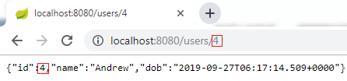

Implementing the POST Method to create User Resource
In the previous few steps, we have created simple RESTful services. In this section, we will use the POST method to post the user resource for the specific URI "/users."
Here we are using two annotations, @RequestBody and @PathMapping.

@RequestBody
The @RequestBody annotation maps body of the web request to the method parameter. The body of the request is passed through an HttpMessageConverter. It resolves the method argument depending on the content type of the request. Optionally, automatic validation can be applied by annotating the argument with @Valid.
In the following example, when we pass the @RequestBody annotation in the createUser() method, it maps to the user parameter.

@PathMapping
The @PathMapping annotation is the specialized version of the @RequestMapping annotation which acts as a shortcut for @RequestMapping(method=RequestMethod=POST). @PostMapping method handles the Http POST requests matched with the specified URI.
Let's create a user resource and post that resource through the POST method.
Step 1: Open UserResource.java and add @PostMapping("/user").
Step 2: Create a method createUser() and pass the User class's object as the body of the web.
Step 3: Save the created user.
UserResource.java
- package com.javatpoint.server.main.user;
- import java.util.List;
- import org.springframework.beans.factory.annotation.Autowired;
- import org.springframework.web.bind.annotation.GetMapping;
- import org.springframework.web.bind.annotation.PathVariable;
- import org.springframework.web.bind.annotation.PostMapping;
- import org.springframework.web.bind.annotation.RequestBody;
- import org.springframework.web.bind.annotation.RestController;
- @RestController
- public class UserResource
- {
- @Autowired
- private UserDaoService service;
- @GetMapping("/users")
- public List<User> retriveAllUsers()
- {
- return service.findAll();
- }
- //retrieves a specific user detail
- @GetMapping("/users/{id}")
- public User retriveUser(@PathVariable int id)
- {
- return service.findOne(id);
- }
- //method that posts a new user detail
- @PostMapping("/users")
- public void createUser(@RequestBody User user)
- {
- User sevedUser=service.save(user);
- }
- }
When we refresh the page it returns the get request. But we need to send POST request. We can send POST request through REST client. REST client is a client that is designed to use a service (RESTful) from a server.
Lets' see how to use the REST client.
Step 4: Download the Postman from https://www.getpostman.com/downloads/.
Or add Google Chrome extension in the browser https://bit.ly/1HCOCwF.
Step 5: Launch the Postman and Signup. Create a user name. Here we have created user name javatpoint and clicked on Submit button. Consider the below image:
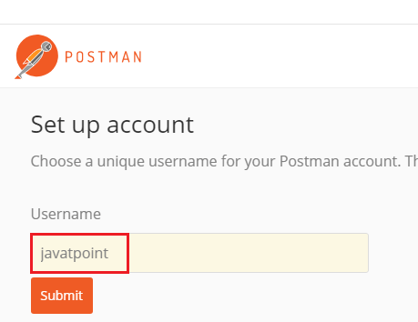
Step 6: First, we check for the GET request. Type the URL http://localhost:8080/users/1 in the address bar and click on the Send button. It returns the detail of the first user.
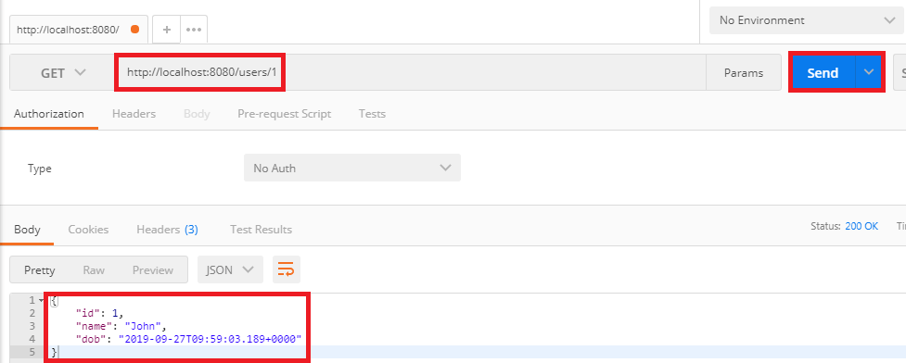
Step 7: Now we send a POST request.
- Change the method to the POST.
- Copy the body of the response coming from "/users/1".
- Click on Body tab. Now we create a body for the POST request.
- Choose the raw option. It creates a raw request.
- Paste the copied content.
- Remove the id because it increments automatically.
- Change the "name": "Thomas".
- Instead of Text we are sending the data in the JSON format. So select JSON (application/json).
- Type the URL http://localhost:8080/users and click on the Send button.
- Click on the Get request on the left side of the window.
- Now we will send a Get request again, so change the URL http://localhost:8080/users and click on the Send button. It displays all the users, including which we have created.
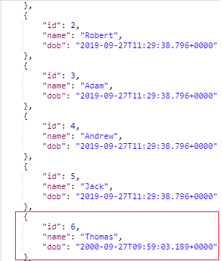

Enhancing POST Method to Return Correct HTTP Code and Status Location
In this section, we will return the status (Created) and URI ("/users/6") of the user recourse which we have created.

ResponseEntity Class
The ResponseEntity is a class which extends HttpEntity and HttpStatus class. It is defined in org.springframework.http.RequestEntity.
- It is used in RestTemplate and @Controller methods.
- It is used as parameter in getForEntity() and exchange() method.
- It is also used in Spring MVC, as a parameter in a @Controller method.

created() method of RequestEntity Class
The created() method is the static method of RequestEntity class. It creates a new builder with a CREATED status and a location header set to the given URI.
Syntax
- public static ResponseEntity.BodyBuilder created(URI location)
Parameter: It accepts the location URI as a parameter.
Returns: It returns the created builder.
All Http status codes are Enum constant, which is defined in the HttpStatus class.

ServletUriComponentsBuilder
The ServletUriComponentsBuilder is a class which is defined in org.springframework.web.servlet.support.ServletUriComponentsBuilder. It extends UriComponentsBuilder class. It has additional static factory methods to create a link based on the current HttpServletRequest.

fromCurrentRequest() method
It is similar to fromRequest(HttpServletRequest) method except the request is obtained through RequestContextHolder.

path() method
The path() is the method of UriComponentsBuilder class. It appends the given path to the existing path of this builder. The given path may contain URI template variable.
Syntax
- public UriBuilderBuilder path(String path)
Parameter: It accepts a path as a parameter.
Returns: It returns the UriComponentsBuilder.

buildAndExpand() method
It builds UriComponents instance and replaces URI template variables with the values obtained from an array. It is the shortcut method which combines calls to build() and then UriComponents.expand(Object... uriVariableValues).
Syntax
- public UriComponents buildAndExpand(Object...uriVariableValues)
Parameter: It accepts the URI variable values as a parameter.
Returns: It returns the URI components with extended values.

build() method
It builds UriComponents instance from the various components contained in the builder.
Syntax
- public UriComponents build()
Parameter: It does not accept any parameter.
Returns: It returns the Uri Components.
Let's see how to return the status of the created resource and how to set URI of the created resource in the response.
Step 1: Create a method that creates a user resource and returns the ResponseEntity.
UserResource.java
- package com.javatpoint.server.main.user;
- import java.net.URI;
- import java.util.List;
- import org.springframework.beans.factory.annotation.Autowired;
- import org.springframework.http.ResponseEntity;
- import org.springframework.web.bind.annotation.GetMapping;
- import org.springframework.web.bind.annotation.PathVariable;
- import org.springframework.web.bind.annotation.PostMapping;
- import org.springframework.web.bind.annotation.RequestBody;
- import org.springframework.web.bind.annotation.RestController;
- import org.springframework.web.servlet.support.ServletUriComponentsBuilder;
- @RestController
- public class UserResource
- {
- @Autowired
- private UserDaoService service;
- @GetMapping("/users")
- public List<User> retriveAllUsers()
- {
- return service.findAll();
- }
- //retrieves a specific user detail
- @GetMapping("/users/{id}")
- public User retriveUser(@PathVariable int id)
- {
- return service.findOne(id);
- }
- //method that posts a new user detail and returns the status of HTTP and location of the user resource
- @PostMapping("/users")
- public ResponseEntity<Object> createUser(@RequestBody User user)
- {
- User sevedUser=service.save(user);
- URI location=ServletUriComponentsBuilder.fromCurrentRequest().path("/{id}").buildAndExpand(sevedUser.getId()).toUri();
- return ResponseEntity.created(location).build();
- }
- }
Step 2: Now open REST client Postman and create a POST request.
Step 3: Click on the POST request under the History tab.
Step 4: Click on the Body tab and change the user name to James.
Step 5: Ensure that you have selected JSON (application/json) media type.
Step 5: Click on the Send button.
On the right-hand side of the window, we can see the Status: 201 Created. It means resource has been properly created.
Step 6: Now click on the Headers tab to see the location. Location is the URI of the created resource. It shows the location of the created user James that is "/users/6".
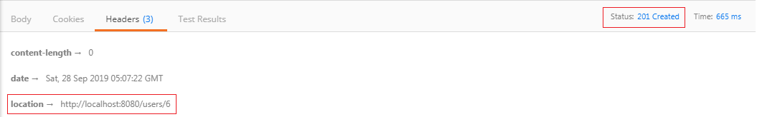
If the client wants to know where the user resources was created, just pick up the location from the header of the response.

Implementing Exception Handling- 404 Resource Not Found
In the previous section, we had returned the proper response status of CREATED when we created the resource. In this section, we will discuss what should be the response when a user resource does not exist.
Let's try and execute a simple response.
Step 1: Open Rest client Postman and select the Get method.
Step 2: Click on the History tab and choose the Get request.
Step 3: Type the URI http://localhost:8080/users/{id}. The user id should not exist.
Step 4: Click on the Send Button.
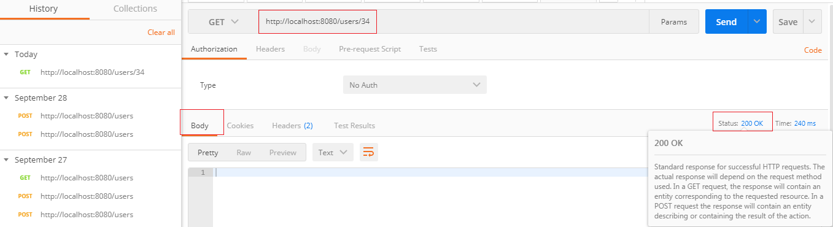
We get the Status: 200 OK and empty body which is a successful response even though the resource does not exist. But it is not the proper response when a resource does not exist.
Let's fix that first.
Step 1: Open the UserResource.java file.
Step 2: Create a UserNotFoundException. It is a checked exception.
- @GetMapping("/users/{id}")
- public User retriveUser(@PathVariable int id)
- {
- User user= service.findOne(id);
- if(user==null)
- //runtime exception
- throw new UserNotFoundException("id: "+ id);
- return user;
- }
Step 3: Create UserNotFoundException class.
Step 4: Generate Constructors from Superclass.
Right-click on the file -> Source -> Generate Constructors from Superclass... -> check the RuntimeException(String) -> Generate.
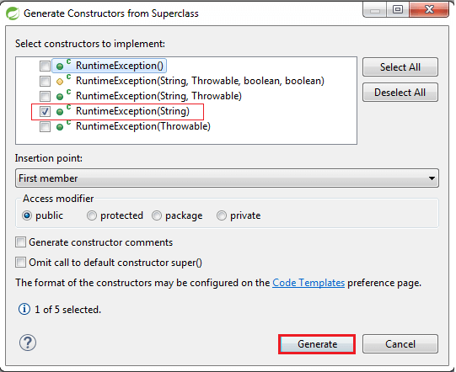
UserNotFoundException.java
- package com.javatpoint.server.main.user;
- public class UserNotFoundException extends RuntimeException
- {
- public UserNotFoundException(String message)
- {
- super(message);
- }
- }
Step 5: Open the Rest Client Postman and generate a Get response as we have done before. It shows the Status: 500 Internal Server Error.
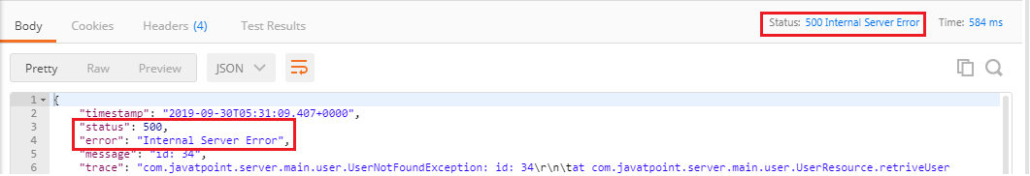
But the Status: 500 Internal Server Error is not the appropriate response for the resource not found. So, we will add an annotation @ResponseStatus to generate the Status: 404 Not Found.
UserNotFoundException.java
- package com.javatpoint.server.main.user;
- import org.springframework.http.HttpStatus;
- import org.springframework.web.bind.annotation.ResponseStatus;
- @ResponseStatus(HttpStatus.NOT_FOUND)
- public class UserNotFoundException extends RuntimeException
- {
- public UserNotFoundException(String message)
- {
- super(message);
- }
- }
Step 6: Again move to Postman and generate a Get request.
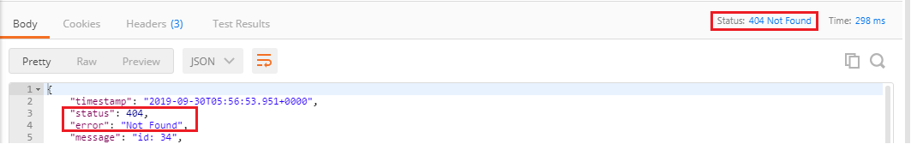
We get the proper response Status: 404 Not Found when a user resource does not exist. The body of the request provided by default error handling that's why we are getting this return status back.
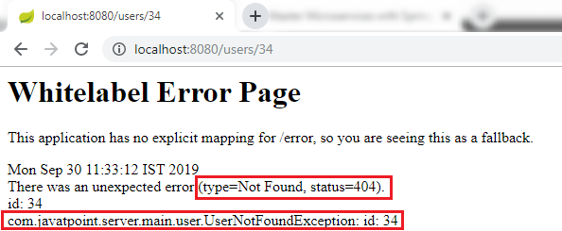
The combination of Spring Boot and Spring Web MVC framework provides error handling. Spring Boot auto-configures some default exception handling. It is important to have a consistent exception message which is obtained for all the services inside our enterprise.
If we have a big organization and each of the services returns the exception messages in a different way, so it is not good. It would be good if we define a standard exception structure which is followed by across all the RESTful Services.

Implementing Generic Exception Handling for all Resources
As we discussed earlier that we should define a standard exception structure which is followed across all the RESTful services. In this section, we will discuss the implementation of generic exception handling for all resources.
Let's see how to customize the exception message.
Step 1: Create a new package with name com.javatpoint.server.main.exception.
Step 2: Create a class with the name ExceptionResponse in the above package.
Step 3: At the basic level, there are three crucial things for the exception structure: timestamp, message, and detail. Define these three fields.
Step 4: Generate Constructors using Fields.
Step 5: Generate Getters, Setters are not needed.
Once the structure is defined, we can define Java implementation for it. Whenever an exception occurs, we would return a response in the specific format. The structure is the most important part and must have to be language independent.
One of the important class in Spring Framework is ResponseEntityExceptionHandler class. It is an abstract and base class for the exceptions that provide centralized exception handling across all the different exception handler methods. We will extend this class to handle and provide customized exception handling functionality. This exception handling functionality is applied to all controller as HellowWorldController, UserResource (Controller).
Step 6: Create a new class with name CustomizedResponseEntityExceptionHandler in the package com.javatpoint.server.main.exception and extends ResponseEntityExceptionHandler class.
Step 7: Add @ControllerAdvice and @RestController annotations.
Step 8: Expand Maven Dependencies in the package explorer -> Expand spring-webmvc-5.1.9.RELEASE.jar -> Expand org.springframework.web.servlet.mvc.method.annotation -> Open ResponseEntityExceptionHandler.class.
Step 9: Copy the ResponseEntityMethod<Object> method from ResponseEntityExceptionHandler.class and paste in CustomizedResponseEntityExceptionHandler.java file.
Step 10: Override the ResponseEntityMethod method. Rename the method name as handleAllExceptions().
Step 11: Create the exception response structure.
Step 12: Create a ResponseEntity object and pass the exception response and Http status as arguments.
CustomizedResponseEntityExceptionHandler.java
- package com.javatpoint.server.main;
- import java.util.Date;
- import org.springframework.http.HttpStatus;
- import org.springframework.http.ResponseEntity;
- import org.springframework.web.bind.annotation.ControllerAdvice;
- import org.springframework.web.bind.annotation.ExceptionHandler;
- import org.springframework.web.bind.annotation.RestController;
- import org.springframework.web.context.request.WebRequest;
- import org.springframework.web.servlet.mvc.method.annotation.ResponseEntityExceptionHandler;
- import com.javatpoint.server.main.exception.ExceptionResponse;
- //defining exception handling for all the exceptions
- @ControllerAdvice
- @RestController
- public class CustomizedResponseEntityExceptionHandler extends ResponseEntityExceptionHandler
- {
- @ExceptionHandler(Exception.class)
- //override method of ResponseEntityExceptionHandler class
- public final ResponseEntity<Object> handleAllExceptions(Exception ex, WebRequest request)
- {
- //creating exception response structure
- ExceptionResponse exceptionResponse= new ExceptionResponse(new Date(), ex.getMessage(), request.getDescription(false));
- //returning exception structure and specific status
- return new ResponseEntity(exceptionResponse, HttpStatus.INTERNAL_SERVER_ERROR);
- }
- }
Step 13: Open rest client Postman and send a Get request. We get the Status: 500 Internal Server Error and exception structure which we have defined.
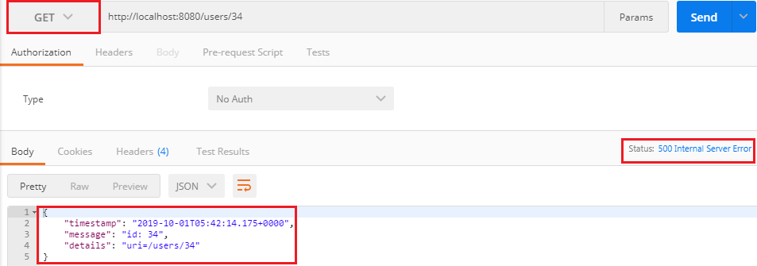
If we want to customize the status Internal Server Error to Not Found, we are required to change a few things in CustomizedResponseEntityExceptionHandler.java file.
CustomizedResponseEntityExceptionHandler.java
- package com.javatpoint.server.main;
- import java.util.Date;
- import org.springframework.http.HttpStatus;
- import org.springframework.http.ResponseEntity;
- import org.springframework.web.bind.annotation.ControllerAdvice;
- import org.springframework.web.bind.annotation.ExceptionHandler;
- import org.springframework.web.bind.annotation.RestController;
- import org.springframework.web.context.request.WebRequest;
- import org.springframework.web.servlet.mvc.method.annotation.ResponseEntityExceptionHandler;
- import com.javatpoint.server.main.exception.ExceptionResponse;
- import com.javatpoint.server.main.user.UserNotFoundException;
- //defining exception handling for all the exceptions
- @ControllerAdvice
- @RestController
- public class CustomizedResponseEntityExceptionHandler extends ResponseEntityExceptionHandler
- {
- @ExceptionHandler(Exception.class)
- //override method of ResponseEntityExceptionHandler class
- public final ResponseEntity<Object> handleAllExceptions(Exception ex, WebRequest request)
- {
- //creating exception response structure
- ExceptionResponse exceptionResponse= new ExceptionResponse(new Date(), ex.getMessage(), request.getDescription(false));
- //returning exception structure and Internal Server status
- return new ResponseEntity(exceptionResponse, HttpStatus.INTERNAL_SERVER_ERROR);
- }

- @ExceptionHandler(UserNotFoundException.class)
- //override method of ResponseEntityExceptionHandler class
- public final ResponseEntity<Object> handleUserNotFoundExceptions(UserNotFoundException ex, WebRequest request)
- {
- //creating exception response structure
- ExceptionResponse exceptionResponse= new ExceptionResponse(new Date(), ex.getMessage(), request.getDescription(false));
- //returning exception structure and Not Found status
- return new ResponseEntity(exceptionResponse, HttpStatus.NOT_FOUND);
- }
- }
Again move to Postman and send a Get request. We get the Status: 404 Not Found with the defined exception structure.
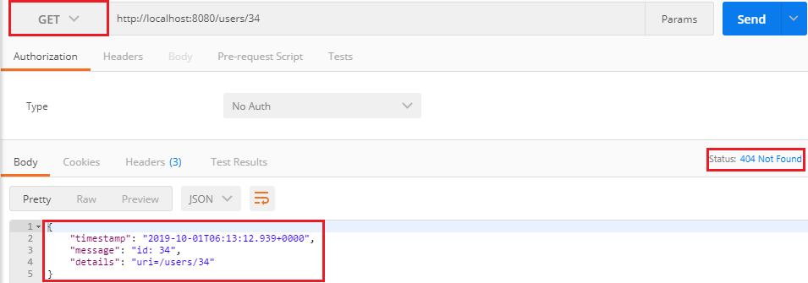

Implementing DELETE Method to Delete a User Resource
In this section, we will implement a delete method to delete a user resource.
Step 1: Open the UserDaoService.java file.
Step 2: Create a method to delete a user resource.
UserDaoService.java
- package com.javatpoint.server.main.user;
- import java.util.ArrayList;
- import java.util.Date;
- import java.util.Iterator;
- import java.util.List;
- import org.springframework.stereotype.Component;
- @Component
- public class UserDaoService
- {
- public static int usersCount=5;
- //creating an instance of ArrayList
- private static List<User> users=new ArrayList<>();
- //static block
- static
- {
- //adding users to the list
- users.add(new User(1, "John", new Date()));
- users.add(new User(2, "Robert", new Date()));
- users.add(new User(3, "Adam", new Date()));
- users.add(new User(4, "Andrew", new Date()));
- users.add(new User(5, "Jack", new Date()));
- }
- //method that retrieve all users from the list
- public List<User> findAll()
- {
- return users;
- }
- //method that adds a user in the list
- public User save(User user)
- {
- if(user.getId()==null)
- {
- user.setId(++usersCount);
- }
- users.add(user);
- return user;
- }
- //method that find a particular user from the list
- public User findOne(int id)
- {
- for(User user:users)
- {
- if(user.getId()==id)
- return user;
- }
- return null;
- }
- //method that delete a user resource
- public User deleteById(int id)
- {
- Iterator<User> iterator = users.iterator();
- while(iterator.hasNext())
- {
- User user=iterator.next();
- if(user.getId()==id)
- {
- iterator.remove();
- return user; //returns the deleted resource back
- }
- }
- return null;
- }
- }
Step 3: Open the UserResource.java file and create a delete mapping to delete a user resource.
UserResource.java
- package com.javatpoint.server.main.user;
- import java.net.URI;
- import java.util.List;
- import org.springframework.beans.factory.annotation.Autowired;
- import org.springframework.http.ResponseEntity;
- import org.springframework.web.bind.annotation.DeleteMapping;
- import org.springframework.web.bind.annotation.GetMapping;
- import org.springframework.web.bind.annotation.PathVariable;
- import org.springframework.web.bind.annotation.PostMapping;
- import org.springframework.web.bind.annotation.RequestBody;
- import org.springframework.web.bind.annotation.RestController;
- import org.springframework.web.servlet.support.ServletUriComponentsBuilder;
- @RestController
- public class UserResource
- {
- @Autowired
- private UserDaoService service;
- @GetMapping("/users")
- public List<User> retriveAllUsers()
- {
- return service.findAll();
- }
- //retrieves a specific user detail
- @GetMapping("/users/{id}")
- public User retriveUser(@PathVariable int id)
- {
- User user= service.findOne(id);
- if(user==null)
- //runtime exception
- throw new UserNotFoundException("id: "+ id);
- return user;
- }
- //method that delete a user resource
- //if the user deleted successfully it returns status 200 OK otherwise 404 Not Found
- @DeleteMapping("/users/{id}")
- public void deleteUser(@PathVariable int id)
- {
- User user= service.deleteById(id);
- if(user==null)
- //runtime exception
- throw new UserNotFoundException("id: "+ id);
- }
- //method that posts a new user detail and returns the status of the user resource
- @PostMapping("/users")
- public ResponseEntity<Object> createUser(@RequestBody User user)
- {
- User sevedUser=service.save(user);
- URI location=ServletUriComponentsBuilder.fromCurrentRequest().path("/{id}").buildAndExpand(sevedUser.getId()).toUri();
- return ResponseEntity.created(location).build();
- }
- }
Step 4: Open Postman, select DELETE request, and specify the user id which you want to delete. Now click on the Send button.
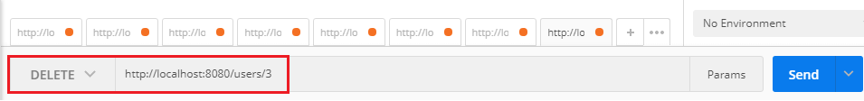
It deletes user id: 3 and returns the Status: 200 Ok. Again send the Get request. It shows all users except user 3.
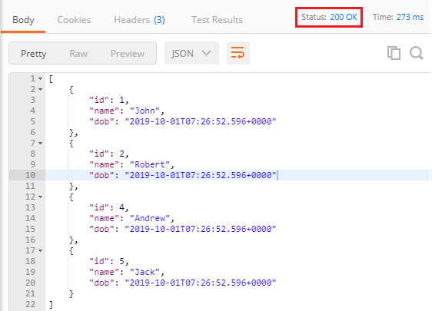
In the following image, we are trying to delete user id: 9, which does not exist. Hence it returns the Status: 404 Not Found.
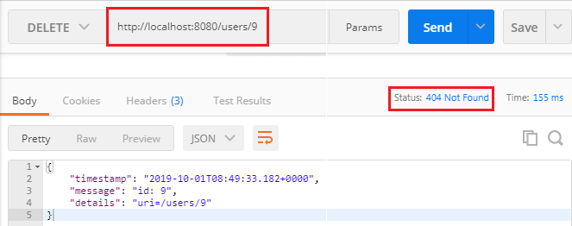

Implementing Validations for RESTful Services
The validation is a common requirement in all the services. We will discuss Java Validation API to add validation in our beans file. When we get a request to create a user, we should validate its content. If it is invalid, we should return a proper response.
Let's see how to validate a request.
Step 1: Open the UserResource.java file.
Step 2: Add @Valid annotation. It is a Javax validation API. Its default classpath is spring-boot-starter-web.
UserResource.java
- package com.javatpoint.server.main.user;
- import java.net.URI;
- import java.util.List;
- import javax.validation.Valid;
- import org.springframework.beans.factory.annotation.Autowired;
- import org.springframework.http.ResponseEntity;
- import org.springframework.web.bind.annotation.DeleteMapping;
- import org.springframework.web.bind.annotation.GetMapping;
- import org.springframework.web.bind.annotation.PathVariable;
- import org.springframework.web.bind.annotation.PostMapping;
- import org.springframework.web.bind.annotation.RequestBody;
- import org.springframework.web.bind.annotation.RestController;
- import org.springframework.web.servlet.support.ServletUriComponentsBuilder;
- @RestController
- public class UserResource
- {
- @Autowired
- private UserDaoService service;
- @GetMapping("/users")
- public List<User> retriveAllUsers()
- {
- return service.findAll();
- }
- //retrieves a specific user detail
- @GetMapping("/users/{id}")
- public User retriveUser(@PathVariable int id)
- {
- User user= service.findOne(id);
- if(user==null)
- //runtime exception
- throw new UserNotFoundException("id: "+ id);
- return user;
- }
- //method that delete a user resource
- @DeleteMapping("/users/{id}")
- public void deleteUser(@PathVariable int id)
- {
- User user= service.deleteById(id);
- if(user==null)
- //runtime exception
- throw new UserNotFoundException("id: "+ id);
- }
- //method that posts a new user detail and returns the status of the user resource
- @PostMapping("/users")
- public ResponseEntity<Object> createUser(@Valid @RequestBody User user)
- {
- User sevedUser=service.save(user);
- URI location=ServletUriComponentsBuilder.fromCurrentRequest().path("/{id}").buildAndExpand(sevedUser.getId()).toUri();
- return ResponseEntity.created(location).build();
- }
- }
Now we will add validations in User class on name and date of birth. Let suppose that name should have at least five characters and date of birth should be in past not in present.
Step 3: Open the User.java file.
Step 4: Add @Size(min=5) annotation just above the name variable.
Step 5: Add @Past annotation just above the dob variable.
User.java
- package com.javatpoint.server.main.user;
- import java.util.Date;
- import javax.validation.constraints.Past;
- import javax.validation.constraints.Size;
- public class User
- {
- private Integer id;
- @Size(min=5)
- private String name;
- @Past
- private Date dob;
- //default constructor
- protected User()
- {

- }
- public User(Integer id, String name, Date dob)
- {
- super();
- this.id = id;
- this.name = name;
- this.dob = dob;
- }
- public Integer getId()
- {
- return id;
- }
- public void setId(Integer id)
- {
- this.id = id;
- }
- public String getName()
- {
- return name;
- }
- public void setName(String name)
- {
- this.name = name;
- }
- public Date getDob()
- {
- return dob;
- }
- public void setDob(Date dob)
- {
- this.dob = dob;
- }
- @Override
- public String toString()
- {
- //return "User [id=" + id + ", name=" + name + ", dob=" + dob + "]";
- return String.format("User [id=%s, name=%s, dob=%s]", id, name, dob);
- }
- }
Step 5: Open the Rest client Postman and send a POST request with new user name Tony k. It returns Status: 201 Created.
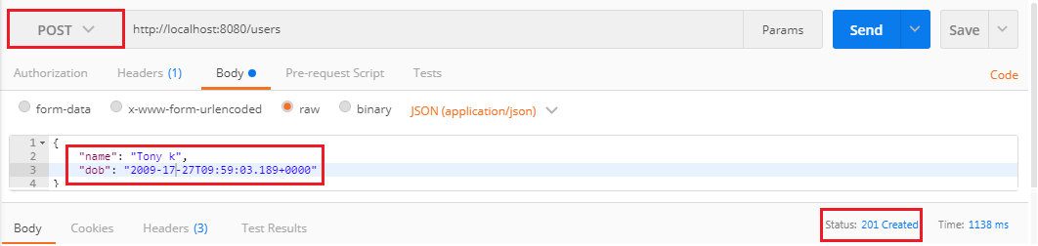
Now we send another POST request. But the name should have less than five characters. It returns the Status: 400 Bad Request.
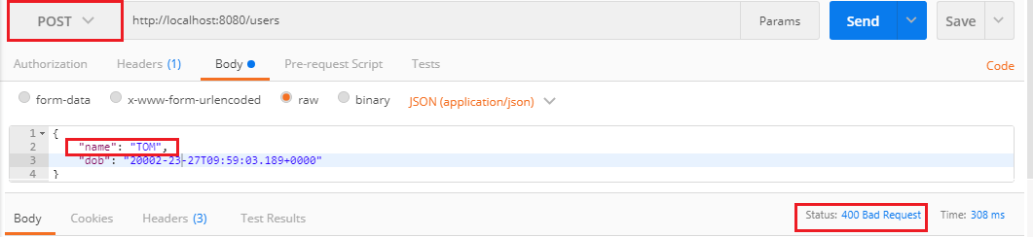
When we create a RESTful services we need to think about consumer that how does the consumer know what is wrong. To resolve this problem we will add a method handleMethodArgumentNotValid() which is defined in the ResponseEntityExceptionHandler class. This is the method which is fired when a bad request occurs.
- protected ResponseEntity<Object> handleMethodArgumentNotValid( MethodArgumentNotValidException ex, HttpHeaders headers, HttpStatus status, WebRequest request)
- {
- return handleExceptionInternal(ex, null, headers, status, request);
- }
Step 6: Copy and paste the above method in CustomizedResponseEntityExceptionHandler.java file.
Step 7: Override the method by adding the annotation @Override.
CustomizedResponseEntityExceptionHandler.java
- package com.javatpoint.server.main;
- import java.util.Date;
- import org.springframework.http.HttpHeaders;
- import org.springframework.http.HttpStatus;
- import org.springframework.http.ResponseEntity;
- import org.springframework.web.bind.MethodArgumentNotValidException;
- import org.springframework.web.bind.annotation.ControllerAdvice;
- import org.springframework.web.bind.annotation.ExceptionHandler;
- import org.springframework.web.bind.annotation.RestController;
- import org.springframework.web.context.request.WebRequest;
- import org.springframework.web.servlet.mvc.method.annotation.ResponseEntityExceptionHandler;
- import com.javatpoint.server.main.exception.ExceptionResponse;
- import com.javatpoint.server.main.user.UserNotFoundException;
- //defining exception handling for all the exceptions
- @ControllerAdvice
- @RestController
- public class CustomizedResponseEntityExceptionHandler extends ResponseEntityExceptionHandler
- {
- @ExceptionHandler(Exception.class)
- //override method of ResponseEntityExceptionHandler class
- public final ResponseEntity<Object> handleAllExceptions(Exception ex, WebRequest request)
- {
- //creating exception response structure
- ExceptionResponse exceptionResponse= new ExceptionResponse(new Date(), ex.getMessage(), request.getDescription(false));
- //returning exception structure and specific status
- return new ResponseEntity(exceptionResponse, HttpStatus.INTERNAL_SERVER_ERROR);
- }
- @ExceptionHandler(UserNotFoundException.class)
- //override method of ResponseEntityExceptionHandler class
- public final ResponseEntity<Object> handleUserNotFoundExceptions(UserNotFoundException ex, WebRequest request)
- {
- //creating exception response structure
- ExceptionResponse exceptionResponse= new ExceptionResponse(new Date(), ex.getMessage(), request.getDescription(false));
- //returning exception structure and specific status
- return new ResponseEntity(exceptionResponse, HttpStatus.NOT_FOUND);
- }
- @Override
- protected ResponseEntity<Object> handleMethodArgumentNotValid(MethodArgumentNotValidException ex, HttpHeaders headers, HttpStatus status, WebRequest request)
- {
- ExceptionResponse exceptionResponse= new ExceptionResponse(new Date(), ex.getMessage(), ex.getBindingResult().toString());
- //returning exception structure and specific status
- return new ResponseEntity(exceptionResponse, HttpStatus.BAD_REQUEST);
- }
- }
Step 8: Now, we send a POST request through Postman. It returns the exception structure with message Validation failed for argument and other details.
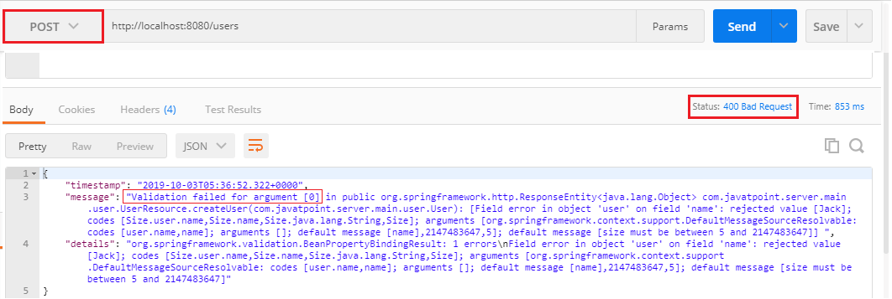
It is difficult to understand the message for the user. So we will now customize the message with the string Validation Failed instead of getting message.
- @Override
- protected ResponseEntity<Object> handleMethodArgumentNotValid(MethodArgumentNotValidException ex, HttpHeaders headers, HttpStatus status, WebRequest request)
- {
- ExceptionResponse exceptionResponse= new ExceptionResponse(new Date(), "Validation Failed", ex.getBindingResult().toString());
- //returning exception structure and specific status
- return new ResponseEntity(exceptionResponse, HttpStatus.BAD_REQUEST);
- }
Step 9: Again send a POST request. It returns the message which we have customized.
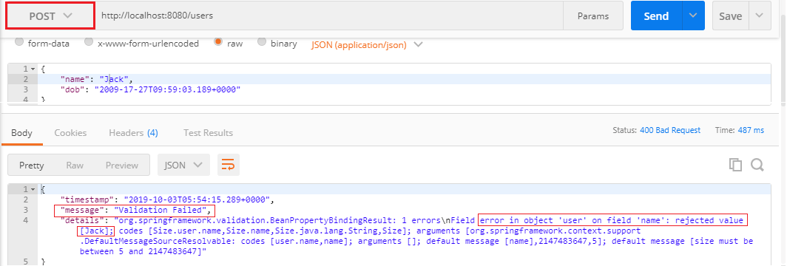
It might be useful for the consumer. Now we customize the message again and make it more error specific.
Step 10: Open User.java file and add an attribute message="Name should have at least 5 characters" in @Size annotation.
- @Size(min=5, message="Name should have at least 5 characters")
Step 11: Again, send a POST request. It returns the more specific exception which we have specified.
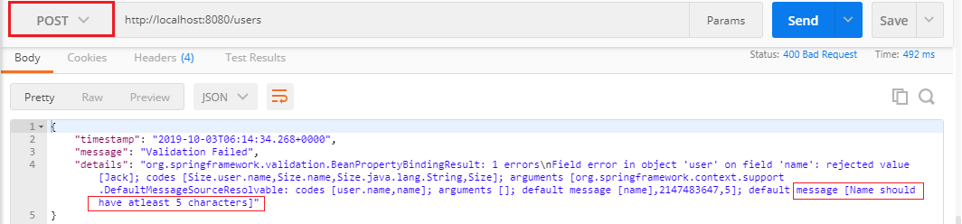
We can further customize the exception by following the BindingResult interface. There is a wide variety of exception messages. There are following validation classes defined in validation-api-2.0.1.Final.jar.
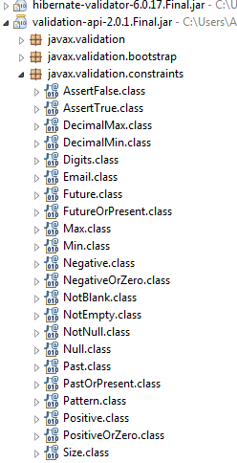

Implementing HATEOAS for RESTful Services

HATEOAS
HATEOAS acronyms for Hypermedia as the Engine of Application State. The term hypermedia refers to content that contains a link to other forms of media like images, movies, and text. It is a component of the REST application that distinguishes it from other network architecture. Using HATEOAS, a client interacts with a network application, whose application server provides information dynamically through Hypermedia.

Spring-HATEOAS
Spring-HATEOAS is the library of APIs. We can use these APIs for creating REST representations that follow the HATEOAS principle while working with Spring MVC.
In the Spring HATEOAS project, we do not require Servlet Context and concatenate the path variable to the base URI. Instead of this, Spring HATEOAS offers three abstractions for creating the URI: ContrrollerLinkBuilder, Link, and Resource Support. We can use these abstractions to create metadata, which associates with the resource representation.
Features
- It supports hypermedia formats like HAL.
- It provides Link builder API to create links pointing to MVC controller methods.
- Model classes for the link, resource representation models.
Spring Boot does the following tasks:
- Configure HAL support
- Register support for entity links
- Wire up message converter support
Suppose, we have requested a GET request for localhost:8080/users/1, it returns the details of user id 1. Along with this, it also returns a field called link that contains a link (localhost:8080/users) of all users so that consumers can retrieve all the users. This concept is called HATEOAS.
Let's implement the HATEOAS in the project.
Step1: Open the pom.xml and add the spring-boot-starter-hateoas dependency.
- <dependency>d
- <groupId>org.springframework.boot</groupId>
- <artifactId>spring-boot-starter-hateoas</artifactId>
- </dependency>
Step 2: Open UserResource.java and copy the retrieveUser() method.
Step 3: Paste the method and make the following changes:
- Create a constructor of Resource class.
- Resource<User> resource = new Resource<User>(User)
Remember that import the Resource class of org.springframework.hateoas package.
- Add a link to retrieve all users by using the ControllerLinkBuilder class. It enables us to create a link from methods.
- Import the ControllerLinkBuilder.
- import static org.springframework.hateoas.mvc.ControllerLinkBuilder.
- Use the method linkTo() of ControllerLinkBuilder class. It creates a new ControllerLinkBuilder with a base of mapping annotated to the given controller class.
- ControllerLinkBuilder linkTo=linkTo(methodOn(this.getClass().retrieveAllUsers());
methodOn() is a wrapper for DummyInvocationUtils.methodOn(class, Object) to be available in case you work with the static import of ControllerLinkBuilder.
- Add this link to the resource with the name which we want to use inside the HATEOAS.
- resource.add(linkTo.withRel("all-users"));
withRel(String rel) is the method that creates the link built by the current builder instance with the given rel. The parameter rel must not be null.
- Return the resource instead of the user.
- Change the return type of method to Resource.
After making the above changes the UserResource.java file look like the following:
UserResource.java
- package com.javatpoint.server.main.user;
- import static org.springframework.hateoas.mvc.ControllerLinkBuilder.*;
- import java.net.URI;
- import java.util.List;
- import javax.validation.Valid;
- import org.springframework.beans.factory.annotation.Autowired;
- import org.springframework.hateoas.Resource;
- import org.springframework.hateoas.mvc.ControllerLinkBuilder;
- import org.springframework.http.ResponseEntity;
- import org.springframework.web.bind.annotation.DeleteMapping;
- import org.springframework.web.bind.annotation.GetMapping;
- import org.springframework.web.bind.annotation.PathVariable;
- import org.springframework.web.bind.annotation.PostMapping;
- import org.springframework.web.bind.annotation.RequestBody;
- import org.springframework.web.bind.annotation.RestController;
- import org.springframework.web.servlet.support.ServletUriComponentsBuilder;
- @RestController
- public class UserResource
- {
- @Autowired
- private UserDaoService service;
- @GetMapping("/users")
- public List<User> retriveAllUsers()
- {
- return service.findAll();
- }
- @GetMapping("/users/{id}")
- public Resource<User> retriveUser(@PathVariable int id)
- {
- User user= service.findOne(id);
- if(user==null)
- //runtime exception
- throw new UserNotFoundException("id: "+ id);
- //"all-users", SERVER_PATH + "/users"
- //retrieveAllUsers
- Resource<User> resource=new Resource<User>(user); //constructor of Resource class
- //add link to retrieve all the users
- ControllerLinkBuilder linkTo=linkTo(methodOn(this.getClass()).retriveAllUsers());
- resource.add(linkTo.withRel("all-users"));
- return resource;
- }
- //method that delete a user resource
- @DeleteMapping("/users/{id}")
- public void deleteUser(@PathVariable int id)
- {
- User user= service.deleteById(id);
- if(user==null)
- //runtime exception
- throw new UserNotFoundException("id: "+ id);
- }
- //method that posts a new user detail and returns the status of the user resource
- @PostMapping("/users")
- public ResponseEntity<Object> createUser(@Valid @RequestBody User user)
- {
- User sevedUser=service.save(user);
- URI location=ServletUriComponentsBuilder.fromCurrentRequest().path("/{id}").buildAndExpand(sevedUser.getId()).toUri();
- return ResponseEntity.created(location).build();
- }
- }
Step 4: Open the REST client Postman and send a GET request.
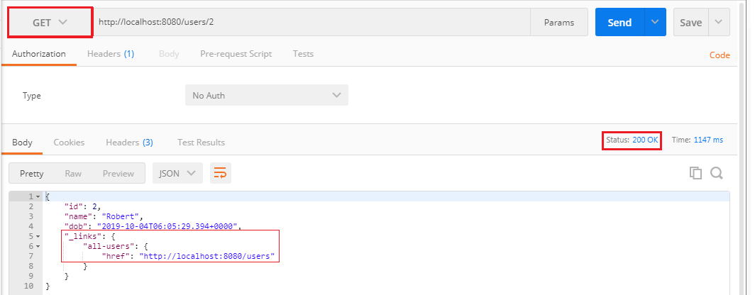
Here we can see that it returns the user along with the link to access all-users. Now click on the link and send a GET request again. It returns the list of all users, as shown in the following image.
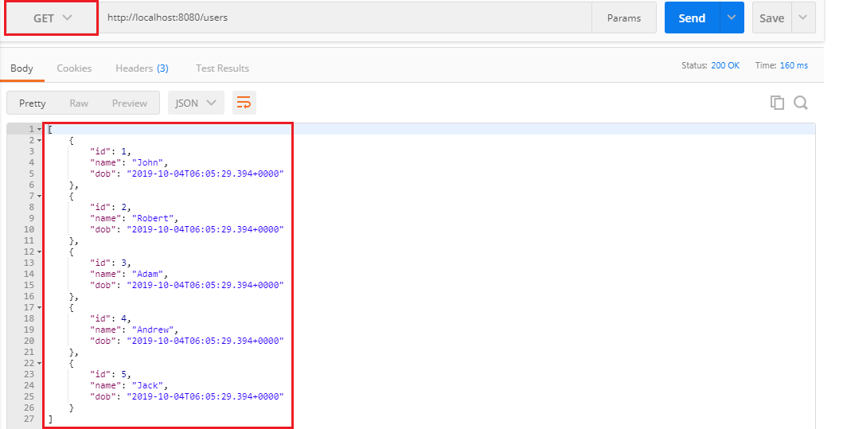

Internationalization of RESTful Services
In this section, we will discuss the Internationalization of the RESTful Web Services.

Internationalization
Internationalization is the process of designing web applications or services in such a way that it can provide support for various countries, various languages automatically without making the changes in the application. It is also known as I18N because the word internationalization has total 18 characters starting from I to N.
Localization is performed by adding locale-specific components such as translated text, data describing locale-specific behavior, etc. It supports full integration into the classes and packages that provide language-or-culture-dependent functionality.
Java provides the foundation for internationalization for desktop and server applications. There are following important internationalized areas of functionality.
- Text Representation: Java is based on the Unicode character set, and several libraries implement the Unicode standard.
- Locale identification and localization: Locale in Java are identifiers that can be used to request locale-specific behavior in different areas of functionality. Localization is supported by ResourceBundle class. The class provides access to local specific objects, including strings.
- Date and time handling: Java provides various calendars. It supports conversion to and from calendar independent Date objects. Java supports all the time zones in the world.
- Text processing: It includes character analysis, case mapping, string comparison, breaking text into words, formatting numbers, dates, and time values into strings or parsing them back from strings. Most of these functions are locale-dependent.
- Character encoding: It supports converting text between Unicode and other character encodings when reading incoming text from the streams or writing outgoing text to the streams.
We need to configure two things to make the service internationalized.
- LocaleResolver
- ResourceBundleMessageSource
Default Locale is Locale.US. If somebody does not specify the location, it returns the default locale. We also need to customize the ResourceBundle. It has a list of properties that are to be internationalized. We will store the properties in ResourceBundle. ResourceBundleMessageSource is a Spring MVC concept for handling properties. After that, we will use MessageSource, and a header called Accept-Language.
Let's configure the internationalization.
Step 1: Open RestfulWebServicesApplication.java file.
Step 2: Configure a Bean for default locale.
- @Bean
- public LocaleResolver localeResolver()
- {
- SessionLocaleResolver localeResolver = new SessionLocaleResolver();
- localeResolver.setDefaultLocale(Locale.US);
- return localeResolver;
- }

Note: Import import org.springframework.web.servlet.LocaleResolver package while importing LocaleResolver.
Step 3: Now, we will store properties in a specific file called messages.properties.
Right-click on src/main/resources folder -> New -> File -> Provide the file name: messages.properties. It contains the default locale message.
messages.properties
- good.morning.message=Good Morning
Step 4: Create another property file with the name messages_fr.properties for French locale. It contains a message for the French locale.
messages_fr.properties
- good.morning.message=Bonjour
Step 5: Read properties and customize them based on the input accept header. Open the RestfulWebServicesApplication.java and configure another Bean for ResourceBundle.
- //configuring ResourceBundle
- @Bean
- public ResourceBundleMessageSource bundleMessageSource()
- {
- ResourceBundleMessageSource messageSource = new ResourceBundleMessageSource();
- messageSource.setBasename("messages");
- return messageSource;
- }
RestfulWebServicesApplication.java
- package com.javatpoint.server.main;
- import java.util.Locale;
- import org.springframework.boot.SpringApplication;
- import org.springframework.boot.autoconfigure.SpringBootApplication;
- import org.springframework.context.annotation.Bean;
- import org.springframework.context.support.ResourceBundleMessageSource;
- import org.springframework.web.servlet.LocaleResolver;
- import org.springframework.web.servlet.i18n.SessionLocaleResolver;
- @SpringBootApplication
- public class RestfulWebServicesApplication
- {
- public static void main(String[] args)
- {
- SpringApplication.run(RestfulWebServicesApplication.class, args);
- }
- //configuring default locale
- @Bean
- public LocaleResolver localeResolver()
- {
- SessionLocaleResolver localeResolver = new SessionLocaleResolver();
- localeResolver.setDefaultLocale(Locale.US);
- return localeResolver;
- }
- //configuring ResourceBundle
- @Bean
- public ResourceBundleMessageSource messageSource()
- {
- ResourceBundleMessageSource messageSource = new ResourceBundleMessageSource();
- messageSource.setBasename("messages");
- return messageSource;
- }
- }
Step 6: Update the service to use these sources. Open the HelloWorldController.java and autowired the MessageSource.
- @Autowired
- private MessageSource messageSource;
HelloWorldController.java
- package com.javatpoint.server.main.helloworld;
- import org.springframework.web.bind.annotation.GetMapping;
- import org.springframework.web.bind.annotation.PathVariable;
- import org.springframework.web.bind.annotation.RequestHeader;
- import org.springframework.web.bind.annotation.RestController;
- import java.util.Locale;
- import org.springframework.beans.factory.annotation.Autowired;
- import org.springframework.context.MessageSource;
- import org.springframework.context.annotation.Configuration;
- @Configuration
- //Controller
- @RestController
- public class HelloWorldController
- {
- @Autowired
- private MessageSource messageSource;
- //using get method and hello-world URI
- @GetMapping(path="/hello-world")
- public String helloWorld()
- {
- return "Hello World";
- }
- @GetMapping(path="/hello-world-bean")
- //method- which returns "Hello World"
- public HelloWorldBean helloWorldBean()
- {
- return new HelloWorldBean("Hello World");//constructor of HelloWorldBean
- }
- //passing a path variable
- //hello-world/path-variable/javatpoint
- @GetMapping(path="/hello-world/path-variable/{name}")
- public HelloWorldBean helloWorldPathVariable(@PathVariable String name)
- {
- return new HelloWorldBean(String.format("Hello World, %s",name)); //%s replace the name
- }
- //internationalization
- @GetMapping(path="/hello-world-internationalized")
- public String helloWorldInternationalized(@RequestHeader(name="Accept-Language", required=false) Locale locale)
- {
- return messageSource.getMessage("good.morning.message", null, locale);
- }
- }
Step 7: Open the REST client Postman and perform the following changes:
- Select the GET request.
- Type the URI http://localhost:8080/hello-world-internationalized
- Click on Headers tab and type:
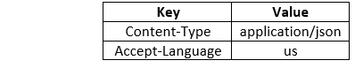
- Click on the Send button.
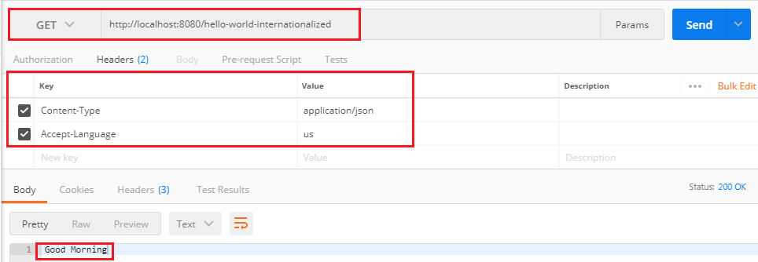
It returns the US locale message Good Morning.
Now we change the RequestHeader us to fr and send a GET request again.
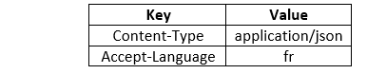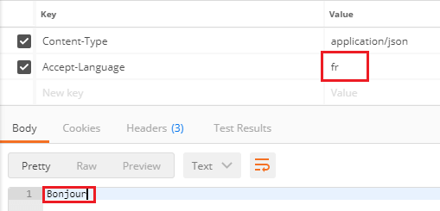
It returns the French locale message Bonjour.
Again, change the RequestHeader fr to other RequestHeader, say nl. It returns the default locale (US) message Good Morning.
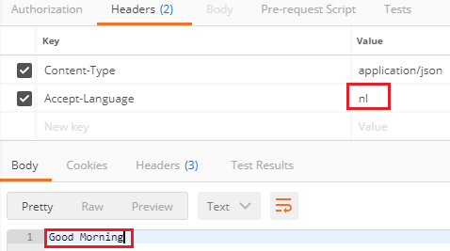
Let's create a property file message_nl.properties for RequestHeader nl. It contains a message Goede Morgen in the Dutch language.
messages_nl.properties
- good.morning.message=Goede Morgen
Again send a GET request that returns the message, Goede Morgen.
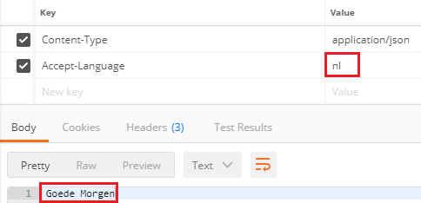

Simplify the Internationalization
Now we will simplify the implementation of internationalization, which we have done above. In the previous implementation, we have accepted locale (a RequestHeader) as a parameter to the REST controller method. If we add this to every method that has to be internationalized, it will increase the cost. Spring provides an alternative way to get it from the LocaleContextHolder.
Let's implement the LocaleContextHolder instead of RequestHeader.
Step 1: Open the HelloWorldController.java and change the return type of the helloWorldInternationalized() method.
- return messageSource.getMessage("good.morning.message", null, LocaleContextHolder.getLocale());
HelloWorldController.java
- package com.javatpoint.server.main.helloworld;
- import org.springframework.web.bind.annotation.GetMapping;
- import org.springframework.web.bind.annotation.PathVariable;
- import org.springframework.web.bind.annotation.RequestHeader;
- import org.springframework.web.bind.annotation.RestController;
- import java.util.Locale;
- import org.springframework.beans.factory.annotation.Autowired;
- import org.springframework.context.MessageSource;
- import org.springframework.context.annotation.Configuration;
- import org.springframework.context.i18n.LocaleContextHolder;
- @Configuration
- //Controller
- @RestController
- public class HelloWorldController
- {
- @Autowired
- private MessageSource messageSource;
- //using get method and hello-world URI
- @GetMapping(path="/hello-world")
- public String helloWorld()
- {
- return "Hello World";
- }
- @GetMapping(path="/hello-world-bean")
- //method- which returns "Hello World"
- public HelloWorldBean helloWorldBean()
- {
- return new HelloWorldBean("Hello World");//constructor of HelloWorldBean
- }
- //passing a path variable
- //hello-world/path-variable/javatpoint
- @GetMapping(path="/hello-world/path-variable/{name}")
- public HelloWorldBean helloWorldPathVariable(@PathVariable String name)
- {
- return new HelloWorldBean(String.format("Hello World, %s",name)); //%s replace the name
- }
- //internationalization
- @GetMapping(path="/hello-world-internationalized")
- public String helloWorldInternationalized(@RequestHeader(name="Accept-Language", required=false) Locale locale)
- {
- return messageSource.getMessage("good.morning.message", null, LocaleContextHolder.getLocale());
- }
- }
Step 2: Open RestfulWebServicesApplication.java and change SessionLocaleResolver to AcceptHeaderLocaleResolver. LocaleResolver implementation uses the primary locale specified in the "accept-language" header of the HTTP request (locale send by the client browser).
RestfulWebServicesApplication.java
- package com.javatpoint.server.main;
- import java.util.Locale;
- import org.springframework.boot.SpringApplication;
- import org.springframework.boot.autoconfigure.SpringBootApplication;
- import org.springframework.context.annotation.Bean;
- import org.springframework.context.support.ResourceBundleMessageSource;
- import org.springframework.web.servlet.LocaleResolver;
- import org.springframework.web.servlet.i18n.AcceptHeaderLocaleResolver;
- import org.springframework.web.servlet.i18n.SessionLocaleResolver;
- @SpringBootApplication
- public class RestfulWebServicesApplication
- {
- public static void main(String[] args)
- {
- SpringApplication.run(RestfulWebServicesApplication.class, args);
- }
- //configuring default locale
- @Bean
- public LocaleResolver localeResolver()
- {
- AcceptHeaderLocaleResolver localeResolver = new AcceptHeaderLocaleResolver();
- localeResolver.setDefaultLocale(Locale.US);
- return localeResolver;
- }
- //configuring ResourceBundle
- @Bean
- public ResourceBundleMessageSource messageSource()
- {
- ResourceBundleMessageSource messageSource = new ResourceBundleMessageSource();
- messageSource.setBasename("messages");
- return messageSource;
- }
- }
The advantage of AcceptHeaderLocaleResolver is that we do not require to configure request header as a parameter in every controller method.
Step 3: Open the REST client Postman and send a GET request by setting the key as Accept-Language and value as fr. It returns the message Bonjour.
Now uncheck the RequestHeader, change the value fr to en. It returns the default locale (US) message Good Morning.
Step 4: Move to RestfulWebServicesApplication.java. Remove the ResourceBundleMessageSource() method and configure it in the application.properties file.
Step 5: Open application.properties file and configure the message basename instead of creating a separate bean in RestfulWebServicesApplication.java.
application.properties
- logging.level.org.springframework=info
- spring.messages.basename=messages
Step 6: Repeat step 3.

Content Negotiation Implementing Support for XML
In this section, we will discuss another concept of RESTful Web Services that is content negotiation.

Content Negotiation
A resource can have many representations, mostly because there may be multiple clients expecting different representations.
Content negotiation is the process of selecting the best representation for a given response when there are multiple representations available. It is a part of HTTP that makes it possible to serve different versions of a document at the same URI.
In web API, content negotiation is performed at the server side to determine the media type formatted to be used based on return the response for an incoming request from the client-side. Content negotiation is centered on the media type and media type formatter.

Server-driven vs. Agent-driven Content Negotiation
An algorithm located at the server makes the selection of representation for a response, which is called server-driven negotiation.
An agent makes the selection of representation for a response, is called agent-driven content negotiation.
So, most of RSET API implementations rely on agent-driven content negotiations. Agent driven content negotiation rely on the usage of HTTP requests or resource URI patterns.

Content negotiation using HTTP headers
An incoming request may have an entity attached to it. To determine the type of entity server uses the HTTP request header Content-Type. There are some common content types are: application/json, application/xml, text/html, images/jpg, etc.
- Content-Type: application/xml
HTTP header ACCEPT is used to determine what type of representation is desired at the client-side. It contains a value as mentioned for Content-Type.
- Accept: application/json
If there is no header is present in the request, the server can send preconfigured default representation type.

Content negotiation using URL patterns
There is another way to pass content type information to the server. The client can use a specific extension in resource URIs. For example, a client can request for the following:
- http://demo.com/product/mobile/samsung/galaxy-s8/functions.xml
- http://demo.com/product/mobile/samsung/ galaxy-s8/functions.json
The first request URI returns the XML response, and the second URI returns the JSON response.

Defining Preferences
The preference is defined through the q parameter that has values between 0 and 1. If the client does not specify the request header, it takes the implicit value, i.e., 1.
If the client is not sure about its desired representation and wants to give multiple values in the accept header. For example:
- Accept: application/json, application/xml;q=0.7,*/*;q=0.5
The above accept header allows you to ask the server for a JSON format. If the JSON format is not present, it will look for XML format. If the XML format is not possible, let it return what it can.
All services we are created until now only work with JSON input and JSON output. If we want to send a GET request by using HTTP header application/xml, it will return the status: 406 Not Acceptable.
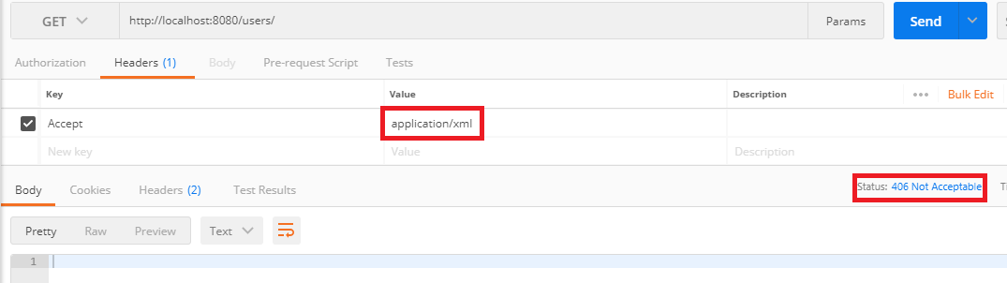
The above image shows that XML is not a valid accept header. Let's see how to implement XML format to one of the representations that are supported.
Step 1: Open pom.xml and add jackson-dataformat-xml dependency.
Step 2: Re-launch the application.
Step 3: Open the REST client Postman and send a GET request by specifying the HTTP header Accept: application/xml.
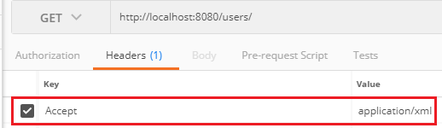
The following image shows the response in XML format.
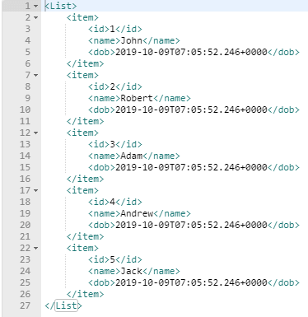
Similarly, we can send a GET request for a specific user.
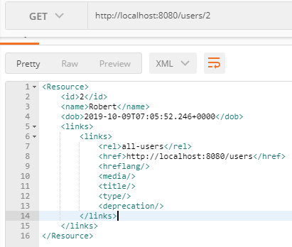
Let's send a POST request using the same HTTP header.
- Under the Header tab add Content-Type: application/xml and Accept: application/xml.
- Select the Body tab.
- Enter the name and dob of the user in XML format.
- Select the XML format XML (application/xml).
- Click on the Send button.
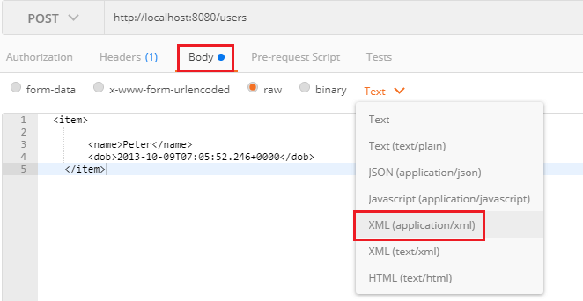
We get the Status: 201 Created. It means that user has been created successfully. Now it can support both the formats XML and JSON.

Configuring Auto Generation of Swagger Documentation

Swagger
A Swagger is an open-source tool. It builds around the OpenAPI Specification that helps developers to design, build, document, and consume RESTful APIs. It is the most popular API documentation format for RESTful Web Services. It provides both JSON and UI support. JSON can be used as a machine-readable format, and Swagger-UI is for visual display, which is easy for humans to understand by just browsing the API documentation. The main Swagger tools are:
- Swagger UI: It creates interactive API documentation.
- Swagger Editor: It is a browser-based editor where we can write OpenAPI specifications.
- Swagger Codegen: It generates server stubs (API implementation stub), and client libraries form an OpenAPI specification.
An OpenAPI Specification (formerly known as Swagger Specification) is an API documentation format for REST APIs. An Open API file allows us to describe our entire API, including:
- Available endpoints (/users) and operations on each endpoint (GET /users, POST /users).
- Operation parameters for each operation.
- Authentication methods.
- Contact information, license, the term of use and other information
Let's generate Swagger documentation for our RESTful services.
Step 1: Open pom.xml and add springfox-swagger2 dependency.
- <dependency>
- <groupId>io.springfox</groupId>
- <artifactId>springfox-swagger2</artifactId>
- <version>2.9.2</version>
- </dependency>
Add another dependency springfox-swagger-ui
- <dependency>
- <groupId>io.springfox</groupId>
- <artifactId>springfox-swagger-ui</artifactId>
- <version>2.9.2</version>
- </dependency>
Now we need to configure Swagger.
Step 2: Create a class with the name SwaggerConfig.java and write the following code.
Docket: A builder that is intended to be the primary interface into the swagger-Spring MVC Framework. Docket provides sensible defaults and convenience methods for configuration.
- package com.javatpoint.server.main;
- import org.springframework.context.annotation.Bean;
- import org.springframework.context.annotation.Configuration;
- import springfox.documentation.spi.DocumentationType;
- import springfox.documentation.spring.web.plugins.Docket;
- import springfox.documentation.swagger2.annotations.EnableSwagger2;
- @Configuration
- //Enable Swagger
- @EnableSwagger2
- public class SwaggerConfig
- {
- //creating bean
- @Bean
- public Docket api()
- {
- //creating constructor of Docket class that accepts parameter DocumentationType
- return new Docket(DocumentationType.SWAGGER_2);
- }
- }
Step 3: Run the application.
Step 4: Open the browser and type the URI http://localhost:8080/v2/api-docs
It shows the complete documentation in JSON format, as shown in the following image. It is not much easy to read and understand. Swagger has provided it to be used in other systems like API management tools that offer functionality like API gateways, API caching, API documentation, etc.
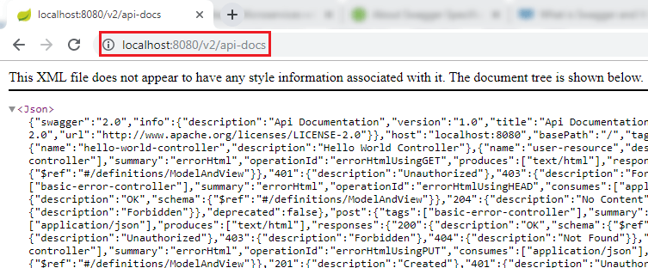
If we want to share the documentation of web service with customers, we can share this JSON file.
Now type the URI http://localhost:8080/swagger-ui.html in the browser. It shows the documentation of the services that we have created.
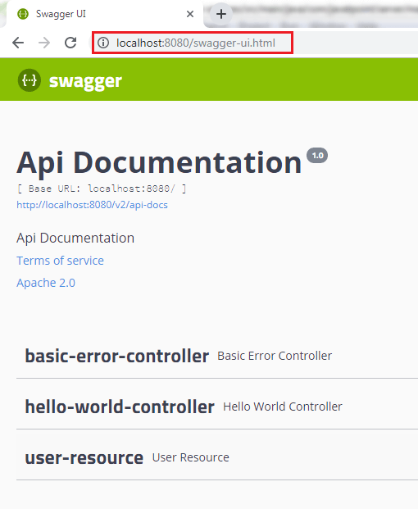
We can also expand the services to see which operations are present in service. In the following image, we have expanded user resource service.
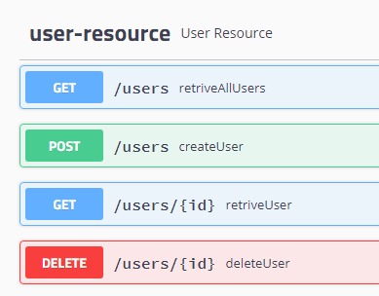

Introduction to Swagger Documentation Format
In this section, we look at the generated documentation in detail. Swagger is a specification for documenting REST API. It specifies the format (URL, method, and representation) to describe REST web services. It also provides tools to generate/compute the documentation from the application code.
As an application developer, we write web services using a framework, Swagger scans application code, and exposes the documentation on URL. A client can consume this URL and learn how to use REST web services: which HTTP methods to call on which URL, which input documents to send, which status code to expect, etc.
We're going to see what is inside the Swagger documentation. When we have a close look at the documentation of the web API, we see some important elements in the starting of the documentation, as shown in the following image.
There are following important swagger elements that are present in the Swagger documentation.
- swagger: It specifies the version specification of Swagger, which we are using.
- info: The info tab contains the information about API like description, version of API, the title of API, termOfServices, and URL.
- host: It specifies the host where we are hosting the service.
- basePath: It is used in URI after the port number and before the API.
- tags: We can assign tags to our resources. It is used to group resources in multiple categories.
- paths: It specifies the path of resources that we are exposing and the different operations that can be performed on these resources.
- definitions: It includes the different elements that we have used in our API.
We will discuss three elements info, paths, and definitions in detail.
Let's see what is inside the info element:
- "info":{"description":"Api Documentation","version":"1.0","title":"Api Documentation","termsOfService":"urn:tos","contact":{},"license":{"name":"Apache 2.0","url":"http://www.apache.org/licenses/LICENSE-2.0"}},
- description: It contains the high level information of API.
- version: It shows the version of API which we are exposing.
- title: It specifies the title of API.
- termOfService: It specifies the term of service, if any.
- contact: It specifies the contact detail of a person, if any.
- license: It specifies the default license Apache 2.0.
Let's expand the path element. It contains all the path that we are exposing.
- paths: {
- /error: {-}
- /hello-world: {-}
- /hello-world-bean: {-}
- /hello-world-internationalized: {-}
- /hello-world/path-variable/{name}: {-}
- /users: {-}
- /users/{id}: {-}
- },
The two most important resources are "/users" and "/users/{id}". These resources exposes the group of users. Let's expand these two resources one by one.
Expanding "/users" resource:
- "/users":{"get":{"tags":["user-resource"],"summary":"retriveAllUsers","operationId":"retriveAllUsersUsingGET","produces":["*/*"],"responses":{"200":{"description":"OK","schema":{"type":"array","items":{"$ref":"#/definitions/User"}}},"401":{"description":"Unauthorized"},"403":{"description":"Forbidden"},"404":{"description":"Not Found"}},"deprecated":false},"post":{"tags":["user-resource"],"summary":"createUser","operationId":"createUserUsingPOST","consumes":["application/json"],"produces":["*/*"],"parameters":[{"in":"body","name":"user","description":"user","required":true,"schema":{"$ref":"#/definitions/User"}}],"responses":{"200":{"description":"OK","schema":{"type":"object"}},"201":{"description":"Created"},"401":{"description":"Unauthorized"},"403":{"description":"Forbidden"},"404":{"description":"Not Found"}},"deprecated":false}},
The above resource contains the two operations get and post that can be performed. We can use get operation to retrieve all the users and post operation to post a user.
Inside the get operation, we get all the response status present there. Response status 200 denotes the successful creation of a user, 401 denotes the unauthorized access of resources, 404 denotes not found, and 403 denotes the forbidden. When we look at the status 200, there is a schema definition. Schema definition shows that we are sending an array of the user as a response. An array of the user is present in the definitions. Similarly, we can also expand the definitions tag to see the definition of the user.
In addition to a POST request, we have parameters that send as part of the body of the request. We accept an input type user as the body of the request.
Expand "/users/{id}" resource:
- "/users/{id}":{"get":{"tags":["user-resource"],"summary":"retriveUser","operationId":"retriveUserUsingGET","produces":["*/*"],"parameters":[{"name":"id","in":"path","description":"id","required":true,"type":"integer","format":"int32"}],"responses":{"200":{"description":"OK","schema":{"$ref":"#/definitions/Resource«User»"}},"401":{"description":"Unauthorized"},"403":{"description":"Forbidden"},"404":{"description":"Not Found"}},"deprecated":false},"delete":{"tags":["user-resource"],"summary":"deleteUser","operationId":"deleteUserUsingDELETE","produces":["*/*"],"parameters":[{"name":"id","in":"path","description":"id","required":true,"type":"integer","format":"int32"}],"responses":{"200":{"description":"OK"},"204":{"description":"No Content"},"401":{"description":"Unauthorized"},"403":{"description":"Forbidden"}},"deprecated":false}}},
The /users/{id} resource allows two operations get and delete. Inside the delete method, there is a parameter called id. This id we are accepting in the path while in the post request, we put content as a part of the body of the request.
Definition defines different kinds of objects that are being used. These definitions are used in the different operations exposed by each resource. When we perform get operation on /users, it returns a list of users. This resource of the user sending back to get the operation of the resource /user/{id} and the resource of the user contains the additional links. The definition of links is also present in the resource of user type.
Links contains a rel and href. A rel is all -users, and href is the link to a particular resource.
There are two ways to expose documentation to the client:
- Download the documentation from http://localhost:8080/v2/api-docs as JSON and send it to clients.
- Share the link of Swagger UI http://localhost:8080/swagger-ui.html. It is a UI that describes all the operations that are ready to expose.

Enhancing Swagger Documentation with Custom Annotations
In the previous section, we have learned about API documentation. We saw a high-level overview structure of the Swagger documentation. In this section, we will customize the Swagger element info. Swagger annotations are defined in the swagger-annotations-1.5.20.jar file.
Step 1: Open the SwaggerConfig.java.
Step 2: Create a constant DEFAULT_API_INFO of type ApiInfo.
- private static final ApiInfo DEFAULT_API_INFO = null;
Step 3: Hold the ctrl key and click on the constant type (ApiInfo). The ApiInfo class will open.
Step 4: Copy the two constants DEFAULT _CONTACT and DEFAULT from the class. or copy the following code and paste it in the SwaggerConfig.java. Rename the constant DEFAULT to DEFAULT_API_INFO.
- public static final Contact DEFAULT_CONTACT = new Contact("", "", "");
- public static final ApiInfo DEFAULT_API_INFO = new ApiInfo("Api Documentation", "Api Documentation", "1.0", "urn:tos", DEFAULT_CONTACT, "Apache 2.0", "http://www.apache.org/licenses/LICENSE-2.0", new ArrayList<VendorExtension>());
Step 5: Configure the contact details of the developer or organization.
- public static final Contact DEFAULT_CONTACT = new Contact("Andrew", "http://www.javatpoint.com", "demo@javatpoint.com");
Step 6: Configure DEFAULT_API_INFO. In this configuration, provide all the information which we want to show in the Swagger documentation.
- public static final ApiInfo DEFAULT_API_INFO = new ApiInfo("RESTful API Demo", "Api Documentation Demo", "1.0", "urn:tos",
- DEFAULT_CONTACT, "Apache 2.0", "http://www.apache.org/licenses/LICENSE-2.0", new ArrayList<VendorExtension>());
SwaggerConfig.java
- package com.javatpoint.server.main;
- import java.util.ArrayList;
- import org.springframework.context.annotation.Bean;
- import org.springframework.context.annotation.Configuration;
- import springfox.documentation.service.ApiInfo;
- import springfox.documentation.service.Contact;
- import springfox.documentation.service.VendorExtension;
- import springfox.documentation.spi.DocumentationType;
- import springfox.documentation.spring.web.plugins.Docket;
- import springfox.documentation.swagger2.annotations.EnableSwagger2;
- //Configuration
- @Configuration
- //Enable Swagger
- @EnableSwagger2
- public class SwaggerConfig
- {
- //configuring the contact detail
- public static final Contact DEFAULT_CONTACT = new Contact("Andrew", "http://www.javatpoint.com", "javatpoint");
- //configuring DEFAULT_API_INFO
- public static final ApiInfo DEFAULT_API_INFO = new ApiInfo("RESTful API Demo", "Api Documentation Demo", "1.0", "urn:tos",
- DEFAULT_CONTACT, "Apache 2.0", "http://www.apache.org/licenses/LICENSE-2.0", new ArrayList<VendorExtension>());
- //creating bean
- @Bean
- public Docket api()
- {
- ApiInfo apiInfo;
- return new Docket(DocumentationType.SWAGGER_2).apiInfo(DEFAULT_API_INFO);
- }
- }
Step 7: Restart the application.
Step 8: Open the browser and type the URI http://localhost:8080/v2/api-docs. It shows the updated contact detail and API info in the documentation.
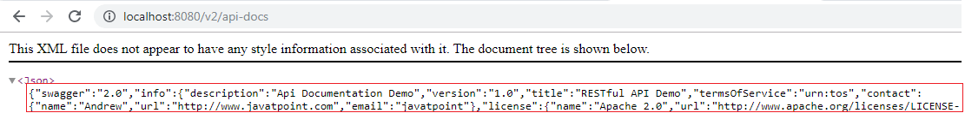

Accepting and producing XML format
We should be more specific about what we produce and what we consume. So, in the next step, we will add content negotiation. We can accept input in application/json or application/xml and produce response in application/json or application/xml format.
Let's specify the content negotiation in our project.
Step 1: In the SwaggerConfig.java, goto the Docket api() and add .produces(DEFAULT_PRODUCES_AND_CONSUMES).consumes(DEFAULT_PRODUCES_AND_CONSUMES).
- return new Docket(DocumentationType.SWAGGER_2).apiInfo(DEFAULT_API_INFO).produces(DEFAULT_PRODUCES_AND_CONSUMES).consumes(DEFAULT_PRODUCES_AND_CONSUMES);
Step 2: Create a constant DEFAULT_PRODUCES_AND_CONSUMES.
- private static final Set<String> DEFAULT_PRODUCES_AND_CONSUMES = null;
Step 3: Create a HashSet and add two values application/json and application/xml.
Note that we cannot directly pass the values to the HashSet. So we have passed a List to the constructor of HashSet.
- private static final Set<String> DEFAULT_PRODUCES_AND_CONSUMES = new HashSet<String>(Array.asList("application/json","appication/xml"));
SwaggerConfig.java
- package com.javatpoint.server.main;
- import java.util.ArrayList;
- import java.util.Arrays;
- import java.util.HashSet;
- import java.util.Set;
- import org.springframework.context.annotation.Bean;
- import org.springframework.context.annotation.Configuration;
- import springfox.documentation.service.ApiInfo;
- import springfox.documentation.service.Contact;
- import springfox.documentation.service.VendorExtension;
- import springfox.documentation.spi.DocumentationType;
- import springfox.documentation.spring.web.plugins.Docket;
- import springfox.documentation.swagger2.annotations.EnableSwagger2;
- //Configuration
- @Configuration
- //Enable Swagger
- @EnableSwagger2
- public class SwaggerConfig
- {
- //configuring the contact detail
- public static final Contact DEFAULT_CONTACT = new Contact("Andrew", "http://www.javatpoint.com", "javatpoint");
- //configuring DEFAULT_API_INFO
- public static final ApiInfo DEFAULT_API_INFO = new ApiInfo("RESTful API Demo", "Api Documentation Demo", "1.0", "urn:tos",
- DEFAULT_CONTACT, "Apache 2.0", "http://www.apache.org/licenses/LICENSE-2.0", new ArrayList<VendorExtension>());
- //two format which we want to produce and consume
- private static final Set<String> DEFAULT_PRODUCES_AND_CONSUMES = new HashSet<String>(Arrays.asList("application/json","appication/xml"));
- //creating bean
- @Bean
- public Docket api()
- {
- ApiInfo apiInfo;
- return new Docket(DocumentationType.SWAGGER_2).apiInfo(DEFAULT_API_INFO).produces(DEFAULT_PRODUCES_AND_CONSUMES).consumes(DEFAULT_PRODUCES_AND_CONSUMES);
- }
- }
Step 4: Open the browser and type the URI http://localhost:8080/v2/api-docs.
The above image shows that it consume and produces JSON and XML format.
We can add more description about user model such as date of birth must be in the past, the name must have at least five characters, etc. Let's add more description in the User model.
Step 1: Open the User.java and add @ApiModel annotation just above the class name. Add the description about the User model.
@ApiModel: It provides additional information about Swagger Models.
We have added the following description:
- @ApiModel(description="All details about the user")
Step 2: Add another annotation @ApiModelProperty just above the dob variable.
@ApiModelProperty: It allows controlling swagger-specific definitions such as values, and additional notes.
- @ApiModelProperty(notes="Birth date should be in the past")
Step 3: Similarly, add @ApiModelProperty annotation for the name variable.
- @ApiModelProperty(notes="name should have atleast 5 characters")
User.java
- package com.javatpoint.server.main.user;
- import java.util.Date;
- import javax.validation.constraints.Past;
- import javax.validation.constraints.Size;
- import io.swagger.annotations.ApiModel;
- import io.swagger.annotations.ApiModelProperty;
- @ApiModel(description="All details about the user")
- public class User
- {
- private Integer id;
- @Size(min=5, message="Name should have atleast 5 characters")
- @ApiModelProperty(notes="name should have atleast 5 characters")
- private String name;
- @Past
- @ApiModelProperty(notes="Birth date should be in the past")
- private Date dob;
- //default constructor
- protected User()
- {

- }
- public User(Integer id, String name, Date dob)
- {
- super();
- this.id = id;
- this.name = name;
- this.dob = dob;
- }
- public Integer getId()
- {
- return id;
- }
- public void setId(Integer id)
- {
- this.id = id;
- }
- public String getName()
- {
- return name;
- }
- public void setName(String name)
- {
- this.name = name;
- }
- public Date getDob()
- {
- return dob;
- }
- public void setDob(Date dob)
- {
- this.dob = dob;
- }
- @Override
- public String toString()
- {
- //return "User [id=" + id + ", name=" + name + ", dob=" + dob + "]";
- return String.format("User [id=%s, name=%s, dob=%s]", id, name, dob);
- }
- }
Step 4: Restart the application.
Step 5: Open the browser and type the URI http://localhost:8080/v2/api-docs. If we look at the description of the User model, the description which we have specified appears here.
The API documentation is much important as API. The consumer of our service should not have any question about how to consume service, what are the different details, how the output looks like, etc. Everything should be clear to the consumer so that the user can understand easily.
Hence, the Swagger documentation is beneficial for the consumer of service. Swagger provides a lot of annotations that can be used to enhance model, operations, and swagger configurations

Monitoring APIs with Spring Boot Actuator

Spring Boot Actuator
Spring Boot provides the actuator to monitor and manage applications effectively. It is a tool that has HTTP endpoints (the place where the resource lives). It is a sub-project of Spring Boot. It adds several production grade services to our application with less effort.
If the performance of a service goes down or failure, we should know the reason as quickly as possible. We need to build monitoring around the API, especially when we build microservices. Spring Boot has great support to provide monitoring.
To use the production-ready features, we will add spring-boot-actuator dependency in pom.xml.
Let's add monitoring service in our Spring Boot project.
Step 1: Open pom.xml and add the following dependencies:
Spring Boot Starter Actuator: It provides a lot of monitoring facilities around your services.
- <dependency>
- <groupId>org.springframework.boot</groupId>
- <artifactId>spring-boot-starter-actuator</artifactId>
- </dependency>
Spring Data Rest HAL Browser: HAL makes our API exportable, and its documentation easily discoverable from within the API itself.
- <dependency>
- <groupId>org.springframework.data</groupId>
- <artifactId>spring-data-rest-hal-browser</artifactId>
- </dependency>
Hypertext Application Language (HAL) is a simple language that gives a consistent and easy way to hyperlink between resources in API. The spring boot starter actuator is actually in the HAL format. HAL browser searches for APIs and identifies the links. It shows the link on the screen so that we can easily browse through the API.
Step 2: Restart the application.
Start 3: Type the URL localhost:8080/actuator in the browser and hit the enter key. If it does not work, use the URL localhost:8080/application.
It launches the actuator that shows the three URLs: self, health, and info.
- {"_links":{"self":{"href":"http://localhost:8080/actuator","templated":false},"health":{"href":"http://localhost:8080/actuator/health","templated":false},"health-component":{"href":"http://localhost:8080/actuator/health/{component}","templated":true},"health-component-instance":{"href":"http://localhost:8080/actuator/health/{component}/{instance}","templated":true},"info":{"href":"http://localhost:8080/actuator/info","templated":false}}}
When we click on the health URL, it shows the health of the application. In the following image, status up denotes that application is running.
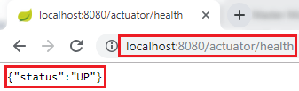
When we click on the info URL, it shows the information of the application. A pair of blank curly braces denote that there is no information is available.
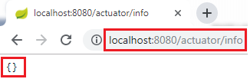
To enable the information, we need to configure the property.
- Open application.properties file and enable web exposure.
- management.endpoints.web.exposure.include=*
- Restart the application.
- Restart the actuator by using the URL localhost:8080/actuator.
It shows a lot of URLs.

The HAL Browser
To access the HAL browser, type localhost:8080 in the browser and hit the enter key.
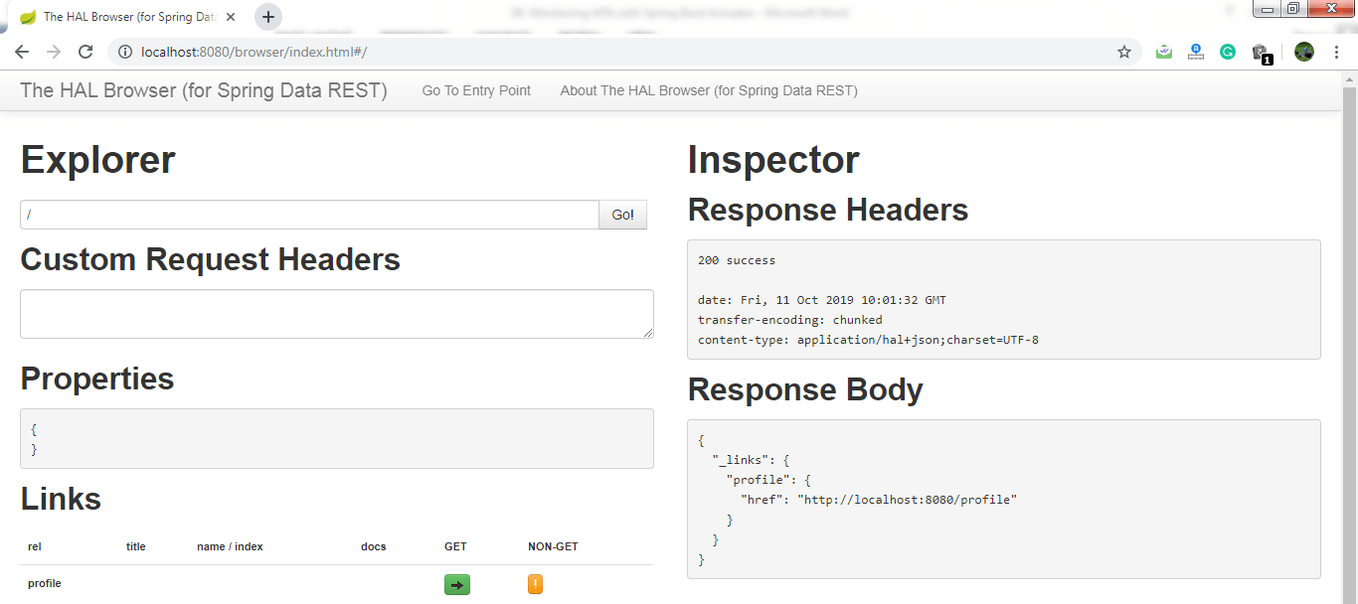
Now we can access the actuator through the HAL browser.
Type /actuator in the Explorer's text box and click on the Go button.
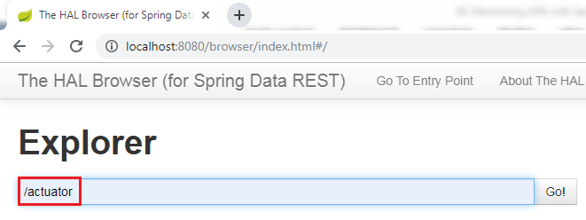
It shows all the things related to the actuator. The most important thing in the actuator is beans.
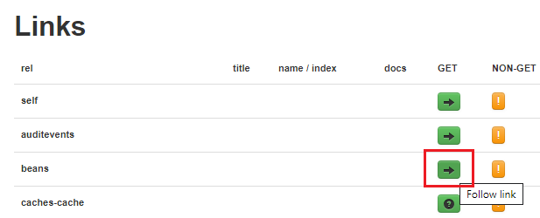
When we click on the bean's arrow, it shows all the beans configured in the spring boot project.
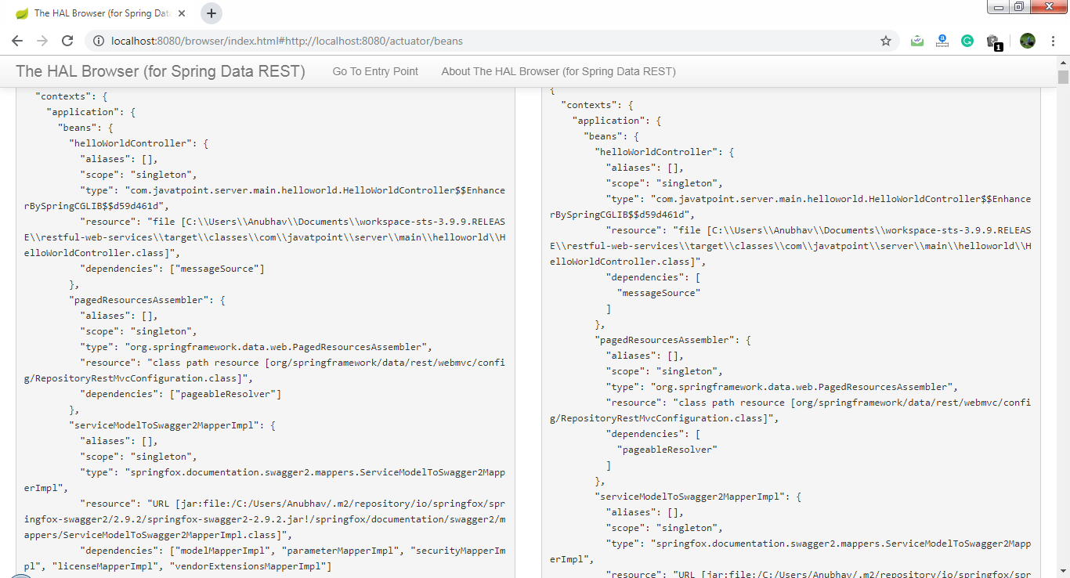
If we want to check the status of the application, we can click on the health link.
It shows the health of the application.
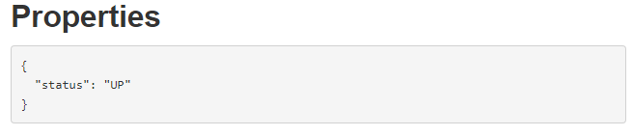
There is another link in the actuator named metrics. It shows the list of valid metrics.
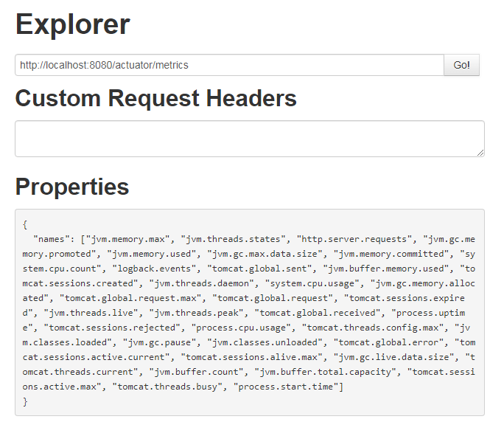
Suppose we want to know how much memory is used by the application. We have accessed /jvm.memory.max.
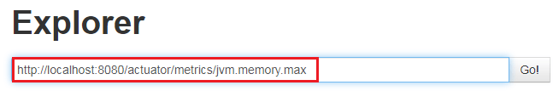
In the following image, the value indicates the maximum memory used by the application.
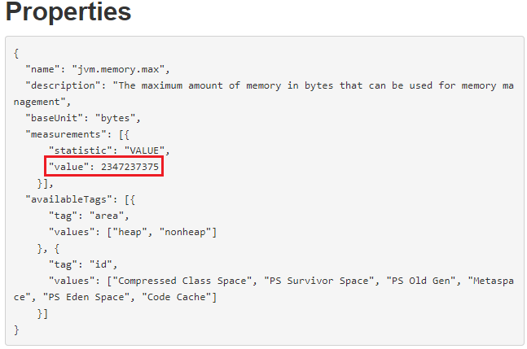
There are two important links httptrace and mapping that are present in the actuator.
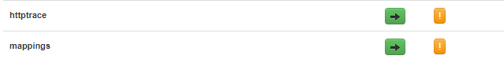
The httptrace shows all the requests that we have executed earlier. We can see all the details of previously executed requests, as shown below:
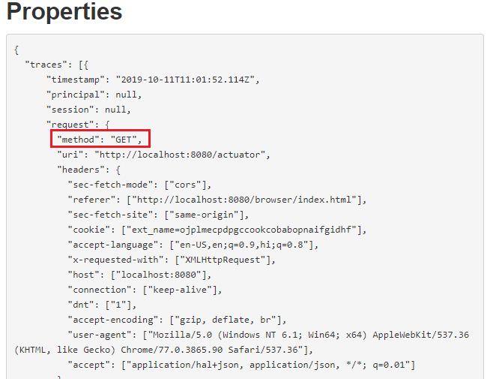
The mapping shows all the different things that are mapped to URLs. Whenever we are creating web services or web applications, we are mapping a lot of URLs.
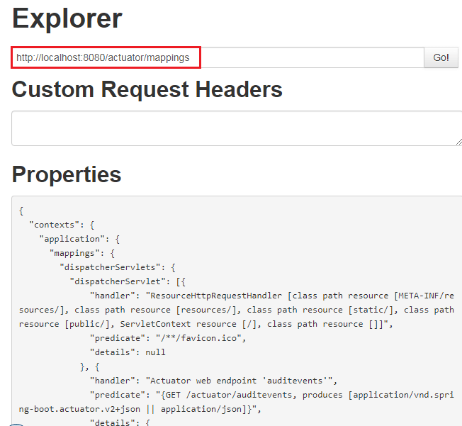
In this section, we have learned what we can do with the actuator.

Implementing Static Filtering for RESTful Services
In this section, we will learn how to filter the request.
Filters are one of the important features provided by the JAX-RS framework. It is used in various contexts. It may be applied on either request to a resource or the response from a resource, or both.
Consider a scenario in which we do not want to show some class members in the response. This process is called filtering. Jackson has two annotations that are used in filtering are: @JsonIgnore and @JsonIgnoreProperties.

@JsonIgnore
It is a member or method level annotation. It expects that the properties to be excluded are marked one by one. If we want to eliminate a member from the process of serialization and deserialization, we can annotate the actual property or its setter or getter.
Let's create a filter that filters the response. We will not touch the user example, but instead of this, we will create a new controller and bean to perform filtering.
Step 1: Create a Controller class with the name FilteringController.java in the package com.javatpoint.server.main.filtering.
Step 2: Create a bean with the name SomeBean.
FilteringController.java
- package com.javatpoint.server.main.filtering;
- import org.springframework.web.bind.annotation.RequestMapping;
- import org.springframework.web.bind.annotation.RestController;
- @RestController
- public class FilteringController
- {
- @RequestMapping("/filtering")
- public SomeBean retrieveSomeBean()
- {
- return new SomeBean("Amit", "9999999999","39000");
- }
- }
Step 3: Create a class with the name SomeBean.java. Define three attributes name, phone, and salary.
Step 4: Generate Constructors.
Step 5: Generate Getters and Setters.
SomeBean.java
- package com.javatpoint.server.main.filtering;
- import com.fasterxml.jackson.annotation.JsonIgnore;
- public class SomeBean
- {
- private String name;
- private String phone;
- //JsonIgnore indicates that the annotated method or field is to be ignored
- @JsonIgnore
- private String salary;
- //generating constructor
- public SomeBean(String name, String phone, String salary)
- {
- super();
- this.name = name;
- this.phone = phone;
- this.salary = salary;
- }
- public String getName()
- {
- return name;
- }
- public void setName(String name)
- {
- this.name = name;
- }
- public String getPhone()
- {
- return phone;
- }
- public void setPhone(String phone)
- {
- this.phone = phone;
- }
- public String getSalary()
- {
- return salary;
- }
- public void setSalary(String salary)
- {
- this.salary = salary;
- }
- }
Step 6: Open the REST client Postman and send the GET request. It returns two fields: name and phone. The field salary will not send with the response.
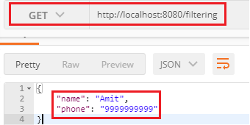
The field salary will not be sent in the response whether we are sending one SomeBean as a response, or a list of SomeBeans as a response.
Step 7: Create another bean that returns a list of SomeBean.
FilteringController.java
- package com.javatpoint.server.main.filtering;
- import java.util.Arrays;
- import java.util.List;
- import org.springframework.web.bind.annotation.RequestMapping;
- import org.springframework.web.bind.annotation.RestController;
- @RestController
- public class FilteringController
- {
- //returning a single bean as response
- @RequestMapping("/filtering")
- public SomeBean retrieveSomeBean()
- {
- return new SomeBean("Amit", "9999999999","39000");
- }
- //returning a list of SomeBeans as response
- @RequestMapping("/filtering-list")
- public List<SomeBean> retrieveListOfSomeBeans()
- {
- return Arrays.asList(new SomeBean("Saurabh", "8888888888","20000"), new SomeBean("Devesh", "1111111111","34000"));
- }
- }
Step 8: Send a GET request again with the URI http://localhost/filtering-list that returns a list of SomeBeans.
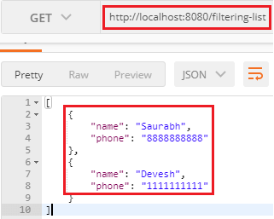
There is another approach to use an annotation @JsonIgnoreProperties.

@JsonIgnoreProperties
@JsonIgnoreProperties is a class-level annotation. It ignores the logical properties in JSON serialization and deserialization.
In the following SomeBean.java file, we have specified the property name and phone, which we want to ignore in the response. These two properties will take part in the JSON serialization and deserialization.
If the property salary is annotated with @JsonIgnore, then all the properties ignored in the JSON serialization and deserialization.
In other words, the union of logical properties ignored by @JsonIgnore and @JsonIgnoreProperties annotation is considered to be ignored in JSON serialization and deserialization.
SomeBean.java
- package com.javatpoint.server.main.filtering;
- import com.fasterxml.jackson.annotation.JsonIgnore;
- import com.fasterxml.jackson.annotation.JsonIgnoreProperties;
- @JsonIgnoreProperties({"name", "phone"})
- public class SomeBean
- {
- private String name;
- private String phone;
- //JsonIgnore indicates that the annotated method or field is to be ignored
- @JsonIgnore
- private String salary;
- //generating constructor
- public SomeBean(String name, String phone, String salary)
- {
- super();
- this.name = name;
- this.phone = phone;
- this.salary = salary;
- }
- public String getName()
- {
- return name;
- }
- public void setName(String name)
- {
- this.name = name;
- }
- public String getPhone()
- {
- return phone;
- }
- public void setPhone(String phone)
- {
- this.phone = phone;
- }
- public String getSalary()
- {
- return salary;
- }
- public void setSalary(String salary)
- {
- this.salary = salary;
- }
- }
When we fire a GET request, it returns an empty list because the properties name and phone are specified in the @JsonIgnoreProperties and the property salary annotated with @JsonIgnore. Hence it returns the empty list.
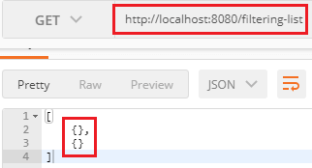
Now remove the annotation @JsonIgnore and again fire a GET request. It returns only the salary property.
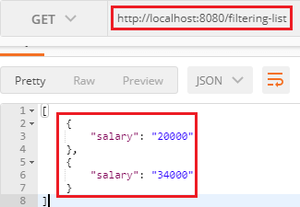
Whatever we have done is called static filtering. Suppose we want to ignore the name in one scenario and the salary in another scenario, we cannot do that using the static filtering. To implement this type of filtering, we use dynamic filtering.

Implementing Dynamic Filtering for RESTful Services
In the previous section, we have performed static filtering. Now we are moving to dynamic filtering.
In the dynamic filtering, we define different filters for different services, according to need. So there exists the concept of dynamic filtering.
Suppose there are three fields: name, phone, and salary. We want to send two fields: name and salary for the first service and name and phone for the second service.
But there is a limitation in dynamic filtering. We cannot configure the dynamic filtering directly in the bean. We need to start configuring filtering, where we are retrieving the values. To implement dynamic filtering, we use a class named MappingJacksonValue. If we look at the class definition, we found the filter method definition there.
Let's see how to implement dynamic filtering in our project.
In the following example, we will send a name and salary for "/filtering" mapping.
Step 1: Open FilteringController.java file.
Step 2: Create a constructor of MappingJacksonValue class and pass a bean (someBean) as a constructor argument. We want to create a mapping Jackson value for this particular bean.
- MappingJacksonValue mapping = new MappingJacksonValue (someBean);
Step 3: To configure the filters, we need to create them. To create a filter, declare local variable filters of type FilterProvider. FilterProvider is an abstract class. It has a single implementation of the SingleFilterProvider method. Invoke the addFilter() method that has two parameters String id and SimpleBeanPropretyFilter filter.
- FilterProvider filters=new SimpleFilterProvider().addFilter("SomeBeanFilter", filter);
Step 4: Invoke the static method filterOutAllExcept() of the class SimpleBeanPropertyFilter class. It filters all the fields in response except the fields which we have specified. We want to send the name and salary field in the response, so we have specified these two fields.
- SimpleBeanPropertyFilter filter=SimpleBeanPropertyFilter.filterOutAllExcept("name", "salary");
Step 5: Configure the filters.
- mapping.setFilters(filters);
Step 6: Instead of returning the someBean return mapping.
- return mapping;
Step 7: We have returned mapping, so we are required to change the return type of the method to MappingJacksonValue.
- public MappingJacksonValue retrieveSomeBean()

- @RequestMapping("/filtering")
- public MappingJacksonValue retrieveSomeBean()
- {
- SomeBean someBean=new SomeBean("Amit", "9999999999","39000");
- //invoking static method filterOutAllExcept()
- SimpleBeanPropertyFilter filter=SimpleBeanPropertyFilter.filterOutAllExcept("name", "salary");
- //creating filter using FilterProvider class
- FilterProvider filters=new SimpleFilterProvider().addFilter("SomeBeanFilter",filter);
- //constructor of MappingJacksonValue class that has bean as constructor argument
- MappingJacksonValue mapping = new MappingJacksonValue(someBean);
- //configuring filters
- mapping.setFilters(filters);
- return mapping;
- }
Remember: The list of valid filters should be defined in the bean. If we don't do that it will return all the fields.
Step 8: Open SomeBean.java file and define a filter by using the annotation @JsonFilter. It is used at class level. It defines a filter name which we filter out properties in JSON serialization.
- @JsonFilter("SomeBeanFilter")
SomeBean.java
- package com.javatpoint.server.main.filtering;
- import com.fasterxml.jackson.annotation.JsonFilter;
- @JsonFilter("SomeBeanFilter")
- public class SomeBean
- {
- private String name;
- private String phone;
- //JsonIgnore indicates that the annotated method or field is to be ignored
- //@JsonIgnore
- private String salary;
- //generating constructor
- public SomeBean(String name, String phone, String salary)
- {
- super();
- this.name = name;
- this.phone = phone;
- this.salary = salary;
- }
- public String getName()
- {
- return name;
- }
- public void setName(String name)
- {
- this.name = name;
- }
- public String getPhone()
- {
- return phone;
- }
- public void setPhone(String phone)
- {
- this.phone = phone;
- }
- public String getSalary()
- {
- return salary;
- }
- public void setSalary(String salary)
- {
- this.salary = salary;
- }
- }
Let's implement the dynamic filtering in the second method. In this method we will return name and phone field for "/filtering-list" mapping.
Step 1: In this method, we first change the return type of the method to MappingJacksonValue.
Step 2: Create a list of SomeBean.
- List<SomeBean> list=Arrays.asList(new SomeBean("Saurabh", "8888888888","20000"), new SomeBean("Devesh", "1111111111","34000"));
Step 3: Specify the field name which we want to send in the response. In our case, we have specified name and phone.
- SimpleBeanPropertyFilter filter=SimpleBeanPropertyFilter.filterOutAllExcept("name", "phone");
Step 4: Pass the list in MappingJacksonValue constructor.
Step 5: Return mapping.
- @RequestMapping("/filtering-list")
- public MappingJacksonValue retrieveListOfSomeBeans()
- {
- List<SomeBean> list=Arrays.asList(new SomeBean("Saurabh", "8888888888","20000"), new SomeBean("Devesh", "1111111111","34000"));
- //invoking static method filterOutAllExcept()
- SimpleBeanPropertyFilter filter=SimpleBeanPropertyFilter.filterOutAllExcept("name", "phone");
- FilterProvider filters=new SimpleFilterProvider().addFilter("SomeBeanFilter",filter);
- //constructor of MappingJacksonValue class that has list as constructor argument
- MappingJacksonValue mapping = new MappingJacksonValue(list);
- //configuring filter
- mapping.setFilters(filters);
- return mapping;
- }
FilteringController.java
- package com.javatpoint.server.main.filtering;
- import java.util.Arrays;
- import java.util.List;
- import org.springframework.http.converter.json.MappingJacksonValue;
- import org.springframework.web.bind.annotation.RequestMapping;
- import org.springframework.web.bind.annotation.RestController;
- import com.fasterxml.jackson.databind.ser.impl.SimpleBeanPropertyFilter;
- import com.fasterxml.jackson.databind.ser.impl.SimpleFilterProvider;
- import com.fasterxml.jackson.databind.ser.FilterProvider;
- @RestController
- public class FilteringController
- {
- //returning a single bean as response
- //values to send name and salary
- @RequestMapping("/filtering")
- public MappingJacksonValue retrieveSomeBean()
- {
- SomeBean someBean=new SomeBean("Amit", "9999999999","39000");
- //invoking static method filterOutAllExcept()
- SimpleBeanPropertyFilter filter=SimpleBeanPropertyFilter.filterOutAllExcept("name", "salary");
- //creating filter using FilterProvider class
- FilterProvider filters=new SimpleFilterProvider().addFilter("SomeBeanFilter",filter);
- //constructor of MappingJacksonValue class that has bean as constructor argument
- MappingJacksonValue mapping = new MappingJacksonValue(someBean);
- //configuring filters
- mapping.setFilters(filters);
- return mapping;
- }
- //returning a list of SomeBeans as response
- //values to send name and phone
- @RequestMapping("/filtering-list")
- public MappingJacksonValue retrieveListOfSomeBeans()
- {
- List<SomeBean> list=Arrays.asList(new SomeBean("Saurabh", "8888888888","20000"), new SomeBean("Devesh", "1111111111","34000"));
- //invoking static method filterOutAllExcept()
- SimpleBeanPropertyFilter filter=SimpleBeanPropertyFilter.filterOutAllExcept("name", "phone");
- FilterProvider filters=new SimpleFilterProvider().addFilter("SomeBeanFilter",filter);
- //constructor of MappingJacksonValue class that has list as constructor argument
- MappingJacksonValue mapping = new MappingJacksonValue(list);
- //configuring filter
- mapping.setFilters(filters);
- return mapping;
- }
- }
Now Open the REST Client Postman and send a GET request with the URI http://localhost:8080/filtering. It returns the two fields name and salary in the response as shown in the following image.
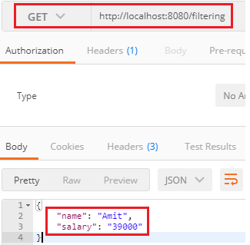
Again, send a GET request with the URI http://localhost:8080/filtering-list. It returns a list with two fields name and phone in the response, as shown in the following image.

Versioning RESTful Web Services-Basic Approach With URIs
Versioning is the most important and difficult part of the API as it takes backward API compatible. Versioning helps us to iterate faster when the changes are identified. We should always version our Web API.
Consider a scenario in which we have a Web API that is up (status) and running. The users are consuming that API. Now we want to add more functionality in the Web API but want to keep the existing functionality unchanged. There may be few users who still want to use the old API while the other users want a new version of API with new or extended features. It is the scenario where Web API versioning comes into existence.

When we required versioning:
When we made a breaking change in Web API, we should up versioned the API. Breaking changes includes:
- A change in the format of the response data for one or more calls.
- Change in the response type.
- Remove any part of the API.
Breaking changes should always result in a change to the major version number for an API or content response type.
Non-breaking changes (adding new points or new response parameters) do not require a change to the major version number. However, it can be helpful to track the minor version of the APIs.

How to Version
The most commonly used approaches fall into three categories:
- URI Versioning
- Versioning using Custom Request Header
- Versioning using Accept Header

URI Versioning
URI versioning is the most straightforward approach. It specified in the URL as a query string. It violates the principle that a URI should refer to a unique resource. You are also guaranteed to break client integration when a version is updated. Twitter uses URI versioning.
Example
http://api.demo.com/v1
http://apiv1.demo.com
The version need not be numeric, nor specified using v[x] syntax. Alternatives include the date, project name, season, or other identifiers that are meaningful enough to change as the version change.

Versioning using Custom Request Header
A custom header allows us to preserve our URLs. It is a duplicate of the content negotiation behavior implemented by the existing Accept header. Version information is specified in the Request Header without the need for any change in the URL. Microsoft uses the request header versioning. The user cannot access request header versioning in the normal browser (chrome). We are required a special plugin to access them on the browser.
Example
Accept-version: v1
Accept-version: v2

Versioning using Accept Header
Accept header define the media type and character encodings. We can also pass version information for Web API through accept headers without changing the URL. It is also known as media type versioning or content negotiation or accept header. Github uses the accept header versioning. The user cannot access accept-header versioning in the normal browser (chrome). We are required a special plugin to access them on the browser.
Example
Accept: application/vnd.demo.v1+json Accept:application/vnd.demo+json;version=1.0
Let's see how to implement versioning in the project.

1.URI Versioning
Step 1: Create a class with the name PersonV1.java in the package com.javatpoint.server.main.versioning. PersonV1 denotes the first version of API. The initial version of API has a name variable.
PersonV1.java
- package com.javatpoint.server.main.versioning;
- public class PersonV1
- {
- private String name;
- }
Step 2: Over a period, we recognize the need for having the first name and last name separately. So we created a class with the name Person2.java. It denotes the second version of API.
PersonV2.java
- package com.javatpoint.server.main.versioning;
- public class PersonV2
- {
- private Name name;
- }
Step 3: Create a class with the name Name.java that has two variables firstName and lastName separately.
Name.java
- package com.javatpoint.server.main.versioning;
- public class Name
- {
- private String firstName;
- private String lastName;
- }
The old version is still returning the full name, and the second version is returning firstName and lastName separately. Now we are required to create two different versions of the same service.
Let's see how to create two different versions of the same service and what are the different versions of the service are present.
Step 4: In the Name.java file, Generate Getters and Setters, Generate Constructor using Fields. Create a no-argument constructor of the class Name.
Name.java
- package com.javatpoint.server.main.versioning;
- public class Name
- {
- private String firstName;
- private String lastName;
- //no argument constructor
- public Name()
- {

- }
- public Name(String firstName, String lastName)
- {
- super();
- this.firstName = firstName;
- this.lastName = lastName;
- }
- public String getFirstName()
- {
- return firstName;
- }
- public void setFirstName(String firstName)
- {
- this.firstName = firstName;
- }
- public String getLastName()
- {
- return lastName;
- }
- public void setLastName(String lastName)
- {
- this.lastName = lastName;
- }
- }
Step 5: Open PersonV1.java class. Generate Getters and Setters, Generate Constructor using Fields. Create a no argument constructor of the class PersonV1.java.
PersonV1.java
- package com.javatpoint.server.main.versioning;
- public class PersonV1
- {
- private String name;
- //no argument constructor
- public PersonV1()
- {
- super();
- }
- public PersonV1(String name)
- {
- super();
- this.name = name;
- }
- public String getName()
- {
- return name;
- }
- public void setName(String name)
- {
- this.name = name;
- }
- }
Step 6: Open PersonV2.java. Generate Getters and Setters, Generate Constructor using Fields. Create a no argument constructor of the class PersonV2.java.
PersonV2.java
- package com.javatpoint.server.main.versioning;
- public class PersonV2
- {
- private Name name;
- public PersonV2()
- {
- super();
- }
- public PersonV2(Name name)
- {
- super();
- this.name = name;
- }
- public Name getName()
- {
- return name;
- }
- public void setName(Name name)
- {
- this.name = name;
- }
- }
Now we need to create a service.
Step 7: Create a class with the name PersonVersioningController.java. Create two methods for different versions and map them to different URIs.
PersonVersioningController.java
- package com.javatpoint.server.main.versioning;
- import org.springframework.web.bind.annotation.RestController;
- import org.springframework.web.bind.annotation.GetMapping;
- @RestController
- public class PersonVersoningController
- {
- //this method is for the first version that returns the entire name
- @GetMapping("v1/person")
- public PersonV1 personv1()
- {
- return new PersonV1("Tom Cruise");
- }
- //this method is for the second version that returns firstName and lastName separately
- @GetMapping("v2/person")
- public PersonV2 personv2()
- {
- return new PersonV2(new Name("Tom", "Cruise"));
- }
- }
Step 8: Open the Postman and send a GET request with the URI http://localhost:8080/v1/person. It returns the full name, as shown in the following image.
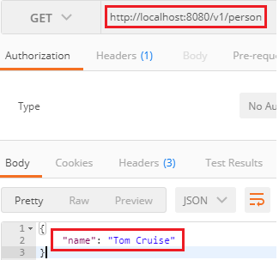
Change the URI http://localhost:8080/v2/person for the second version. It returns the firstName and lastName separately, as shown in the following image.
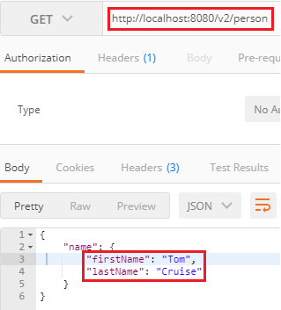

1.1.Versioning using Request Parameter
Another way to implement versioning is by using the request parameter. Amazon uses the request parameter versioning. Open the PersonVersioningController.java and do the following changes:
- Change the URI for the first method from /v1/person to /person/param.
- Change the name of the method from personV1 to paramV1.
- Similarly, change the URI for the second method from /v2/person to /person/param.
Both the methods have the same get mapping, so we will distinguish them by using the value and params attribute. The value attribute contains the URI, which we want to use, and the params attribute contains the parameter which distinguishes between versions.
PersonVersoningController.java
- package com.javatpoint.server.main.versioning;
- import org.springframework.web.bind.annotation.GetMapping;
- import org.springframework.web.bind.annotation.RestController;
- @RestController
- public class PersonVersoningController
- {
- //this method is for first version that returns the entire name
- @GetMapping(value="/person/param", params="version=1")
- public PersonV1 personV1()
- {
- return new PersonV1("Tom Cruise");
- }
- //this method is for second version that returns firstName and lastName separately
- @GetMapping(value="/person/param", params="version=2")
- public PersonV2 personV2()
- {
- return new PersonV2(new Name("Tom", "Cruise"));
- }
- }
Now, move to Postman and send a GET request with the URI http://localhost:8080/person/param?version=1. It returns the full name, as shown in the following image.
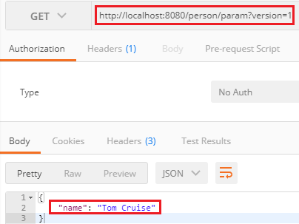
Again, generate a GET request with the URI http://localhost:8080/person/param?version=2 to access the second version. It returns the firstName and lastName separately, as shown in the following image.
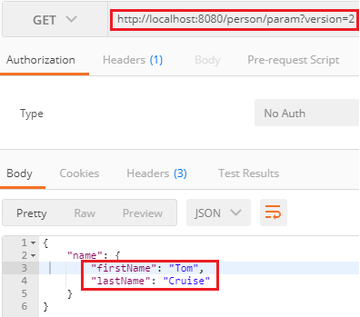

2.Versioning using custom Request Header
There is another option to do versioning using the Request Header. It is similar to content negotiation. In this method, we differentiate service based on the Request Header.
In the PersonVersioningController.java, do the following:
- Copy both the methods and paste in the same file.
- Change the method name paramV1 to headerV1 and paramV2 to headerV2.
- Replace the URI /person/param with /person/header and params with headers.
- /*---------------using request header--------------*/
- //this method is for first version that returns the entire name
- @GetMapping(value="/person/header", headers="X-API-Version=1")
- public PersonV1 headerV1()
- {
- return new PersonV1("Tom Cruise");
- }
- //this method is for second version that returns firstName and lastName separately
- @GetMapping(value="/person/header", headers="X-API-Version=2")
- public PersonV2 headerV2()
- {
- return new PersonV2(new Name("Tom", "Cruise"));
- }
Open the Postman:
- Select the Headers tab and set key: X-API-VERSION and Value: 1.
- Type the URI http://localhost:8080/person/header and send a GET request.
It returns the name full name.
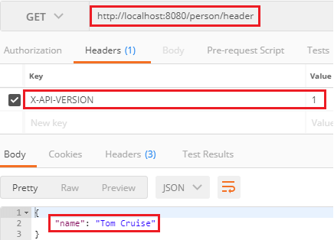
Let's send a GET request for version 2. For this, we need to change the value from 1 to 2 under the Headers tab. It returns the firstName and lastName separately.
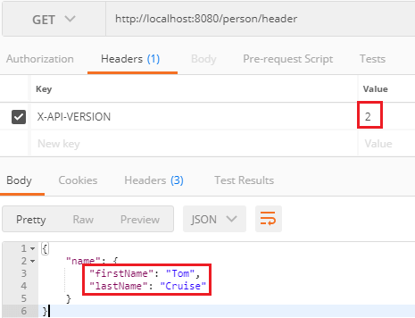

3.Versioning using Accept Header
Another method that is used in versioning is the Accept Header. It is also known as Content Negotiation or Accept Versioning. In this method, we use an attribute called produce. It denotes what kind of output we are generating for the specific service.
In the PersonVersioningController.java file, do the following:
- Copy both the methods and paste in the same file.
- Change the methods name headerV1 to producesV1 and headerV2 to ProducesV2.
- Replace the URI /person/header with /person/produces and header with produces.
- /*---------------using accept header--------------*/
- //this method is for first version that returns the entire name
- @GetMapping(value="/person/produces", produces="application/vnd.company.app-v1+json")
- public PersonV1 producesV1()
- {
- return new PersonV1("Tom Cruise");
- }
- //this method is for second version that returns firstName and lastName separately
- @GetMapping(value="/person/produces", produces="application/vnd.company.app-v2+json")
- public PersonV2 producesV2()
- {
- return new PersonV2(new Name("Tom", "Cruise"));
- }
Open the Postman:
- Select the Headers tab and set key: Accept and Value: application/vnd.company.app-v1+json.
- Uncheck the X-API-VERSION key.
- Type the URI http://localhost:8080/person/produces and send a GET request.
It returns the full name.
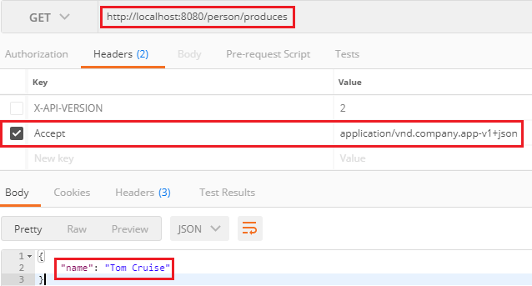
Let's send a GET request for version 2. For this we need to change the value from Value:application/vnd.company.app-v1+json to Value: application/vnd.company.app-v2+json.
It returns the firstName and lastName separately.
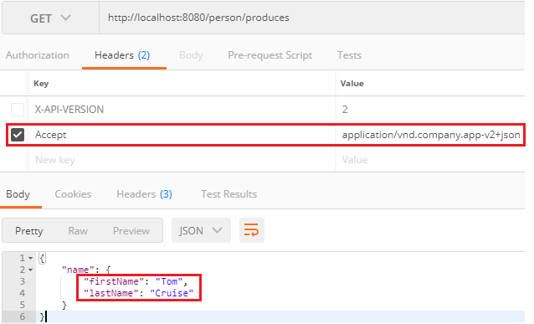

Implementing Basic Authentication with Spring Security
In the previous steps, we have created some resources, but none of them is secure yet. There is no user id and password to access the resources. In this section, we will implement basic authentication.
There are multiple ways to authenticate our RESTful web services. The basic way is to use basic authentication. In the basic authentication, we send a username and password as part of our request. When we provide a username and password, it allows us to access the resource.
There are other advanced forms of authentication like digest authentication, where the password digest is created, and the digest is sent across. It does not send the actual password to the server. The other advanced form of authentication is OAuth (Open Authorization) or OAuth2 authentication.
Let's see how to implement basic authentication in web services.
Step 1: Open pom.xml and add the spring-boot-starter-security. It automatically configures the basic security for us.
- <dependency>
- <groupId>org.springframework.boot</groupId>
- <artifactId>spring-boot-starter-security</artifactId>
- </dependency>
Step 2: Restart the server, we get a password in the log. Each time the server starts up the password will be different.
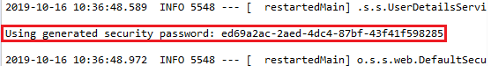
Step 3: Copy the password from the log.
Step 4: Open the REST Client Postman and send a POST request. We are sending a POST to create a user.
- Provide URI http://localhost:8080/users.
- Click on the Body tab and select the raw radio button.
- Select the media type JSON (application/json).
- Provide name and dob.
- Click on the Send button.
It returns the Status: 401 Unauthorized.
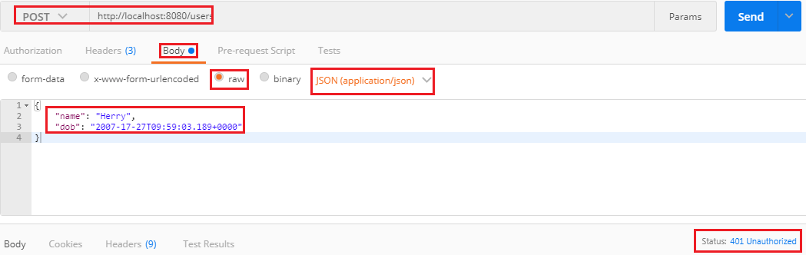
Step 5: In the REST client Postman, click on the Authorization tab and do the following:
- Select the type of authentication Basic Auth.
- Provide the Username. The default username is user.
- Paste the password, which we have copied from the log.
- Click on the Send button.
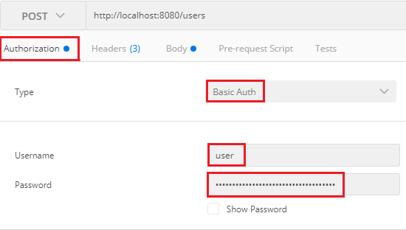
It shows the Status: 201 Created. There is a disadvantage that when we restart the server, the password changes again and again. The solution to this problem is that configure the username and password in the application.properties file.
application.properties
- spring.security.user.name=om
- spring.security.user.password=prakash
Now, move to Postman and try to send a POST request that returns Status: 401 Unauthorized. It is because we are still using an old password. So we are required to change the username and password with the new one. Provide the username and password which we have configured in the properties file. We get the Status: 201 Created.
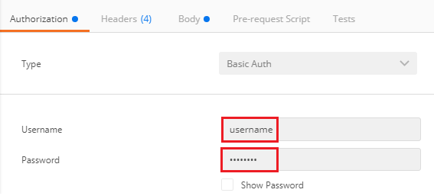

Connecting RESTful Services to JPA
Creating a User Entity and some test Data
Let's create a User entity and a UserRepository so that we can access the detail of the user.
Step 1: Open pom.xml file and add spring-boot-starter-data-jpa dependency.
- <dependency>
- <groupId>org.springframework.boot</groupId>
- <artifactId>spring-boot-starter-data-jpa</artifactId>
- </dependency>
Step 2: Make the User class as an entity by adding an annotation @Entity just above the User class.
@Entity: Entities are nothing but POJO (Plain Old Java Object). It represents the data that can be persisted to the database. It represents a table in a database. Every instance of an entity represents a row in a table. We cannot declare an entity class as final.
Step 3: Make the Id primary key by adding an annotation @Id just above the Id variable. Also, add an annotation @GeneratedValue.
@Id: It defines that the member field below is the primary key of the current entity. Every entity must have a primary key that uniquely defines the column.
@GeneratedValue: The @GeneratedValue annotation may be applied to a primary key property or field of an entity with the @Id annotation. It is used to support the primary key. We have to add the @GeneratedValue annotation to the primary key attribute and choose a generation type. The default generation type is GenerationType.AUTO.
User.java
- package com.javatpoint.server.main.user;
- import java.util.Date;
- import javax.persistence.Entity;
- import javax.persistence.GeneratedValue;
- import javax.persistence.Id;
- import javax.validation.constraints.Past;
- import javax.validation.constraints.Size;
- import io.swagger.annotations.ApiModel;
- import io.swagger.annotations.ApiModelProperty;
- @ApiModel(description="All details about the user")
- @Entity
- public class User
- {
- //making Id as primary key
- @Id
- @GeneratedValue // GenerationType.AUTO.
- private Integer id;
- @Size(min=5, message="Name should have atleast 5 characters")
- @ApiModelProperty(notes="name should have atleast 5 characters")
- private String name;
- @Past
- @ApiModelProperty(notes="Birth date should be in the past")
- private Date dob;
- //default constructor
- protected User()
- {

- }
- public User(Integer id, String name, Date dob)
- {
- super();
- this.id = id;
- this.name = name;
- this.dob = dob;
- }
- public Integer getId()
- {
- return id;
- }
- public void setId(Integer id)
- {
- this.id = id;
- }
- public String getName()
- {
- return name;
- }
- public void setName(String name)
- {
- this.name = name;
- }
- public Date getDob()
- {
- return dob;
- }
- public void setDob(Date dob)
- {
- this.dob = dob;
- }
- @Override
- public String toString()
- {
- //return "User [id=" + id + ", name=" + name + ", dob=" + dob + "]";
- return String.format("User [id=%s, name=%s, dob=%s]", id, name, dob);
- }
- }
Before moving to the next step, remove or comment the basic security dependency in the pom.xml.
Step 4: Open application.properties file and enable the H2 console so that we can see what data we have inserted in the table.
- spring.h2.console.enabled=true
We also need to enable the SQL logging to see which SQL statements are executing. It starts SQL logging in the log when the statement executes.
- spring.jpa.show-sql=true
Now restart the application to pick up the changes. We can see in the following image that the table is created.
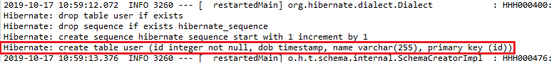
Step 5: We have to create a SQL file to insert data in the user table.
Right-click on the folder src/main/resource -> New ->Other -> Select SQL File -> provide the file name data.sql -> Click on finish.
Step 6: In the data.sql file, insert the data into user table. We have inserted the following data:
- insert into user values(1, sysdate(), om);
- insert into user values(2, sysdate(),riya);
- insert into user values(3, sysdate(), ‘prakash’);
Run the application.
Step 7: Open the browser and type http://localhost:8080/h2-console to connect the H2 console. Make sure that it has JDBC URL: jdbc:h2:mem:testdb. Do not write anything in the password field.
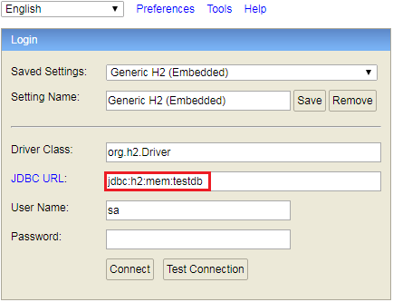
Step 8: Click on the Connect button to login. The table which we have created appears on the left-hand side of the page.
Step 10: Type the query select * from user;
It displays the table of records which we have inserted.
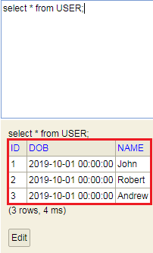

Updating GET Methods on User Resource to Use JPA
In this topic, we will create a service that retrieves all the users.
Still, we are using the UserResource, which talks to the in-memory. Now we will create a new UserResource that will talk to the embedded database. Let's create a new user resource.
Step 1: Copy the UserResource.java file and paste it in the user package. Rename it with UserJPAResource.
Step 2: Now, we have two URIs with the same name that create conflict. To remove this conflict, we will add /jpa in UserJPAResource.java file.
UserJPAResource.java
- package com.javatpoint.server.main.user;
- import static org.springframework.hateoas.mvc.ControllerLinkBuilder.*;
- import java.net.URI;
- import java.util.List;
- import javax.validation.Valid;
- import org.springframework.beans.factory.annotation.Autowired;
- import org.springframework.hateoas.Resource;
- import org.springframework.hateoas.mvc.ControllerLinkBuilder;
- import org.springframework.http.ResponseEntity;
- import org.springframework.web.bind.annotation.DeleteMapping;
- import org.springframework.web.bind.annotation.GetMapping;
- import org.springframework.web.bind.annotation.PathVariable;
- import org.springframework.web.bind.annotation.PostMapping;
- import org.springframework.web.bind.annotation.RequestBody;
- import org.springframework.web.bind.annotation.RestController;
- import org.springframework.web.servlet.support.ServletUriComponentsBuilder;
- @RestController
- public class UserJPAResource
- {
- @Autowired
- private UserDaoService service;
- @GetMapping("/jpa/users")
- public List<User> retriveAllUsers()
- {
- return service.findAll();
- }
- @GetMapping("/jpa/users/{id}")
- public Resource<User> retriveUser(@PathVariable int id)
- {
- User user= service.findOne(id);
- if(user==null)
- //runtime exception
- throw new UserNotFoundException("id: "+ id);
- //"all-users", SERVER_PATH + "/users"
- //retrieveAllUsers
- Resource<User> resource=new Resource<User>(user); //constructor of Resource class
- //add link to retrieve all the users
- ControllerLinkBuilder linkTo=linkTo(methodOn(this.getClass()).retriveAllUsers());
- resource.add(linkTo.withRel("all-users"));
- return resource;
- }
- //method that delete a user resource
- @DeleteMapping("/jpa/users/{id}")
- public void deleteUser(@PathVariable int id)
- {
- User user= service.deleteById(id);
- if(user==null)
- //runtime exception
- throw new UserNotFoundException("id: "+ id);
- }
- //method that posts a new user detail and returns the status of the user resource
- @PostMapping("/jpa/users")
- public ResponseEntity<Object> createUser(@Valid @RequestBody User user)
- {
- User sevedUser=service.save(user);
- URI location=ServletUriComponentsBuilder.fromCurrentRequest().path("/{id}").buildAndExpand(sevedUser.getId()).toUri();
- return ResponseEntity.created(location).build();
- }
- }
But it is not really talking to the database. We need to create a spring data repository.
Step 3: Create an interface with the name UserRepository that extends JpaRepository. Specify the entity that has to be managed. We have specified User and Integer. Now we have the UserRepository ready.
UserRepository.java
- package com.javatpoint.server.main.user;
- import org.springframework.data.jpa.repository.JpaRepository;
- import org.springframework.stereotype.Repository;
- @Repository
- public interface UserRepository extends JpaRepository<User, Integer>
- {

- }
Step 4: Create the use of UserResource. We have autowired the UserRepository interface in the UserJPAResource class.
- @Autowired
- private UserRepository userRepository;
Step 5: Return the userRepository.findAll() in the retriveAllUsers() method.
- @GetMapping("/jpa/users")
- public List<User> retriveAllUsers()
- {
- return userRepository.findAll();
- }
The retriveAllUsers() is the only method that retrieve data form the embedded database, all the other methods retrieve data from the static array list.
Step 6: Open the Postman. Type the URI http://localhost:8080/jpa/users and send a GET request. It shows all the data that is fetched from the embedded database.
Again send a GET request with the URL http://localhost:8080/jpa/users/1. It returns the specified user id, i.e. 1, but it picks up data from memory.
But we are required to fetch data from the embedded database. We need to change the following services in the UserJPAResource.java.
- @GetMapping("/jpa/users")
- public List<User> retriveAllUsers()
- {
- return userRepository.findAll();
- }
In the following service, the findById() returns the Option of User whether user is null or not null. Whenever we use findById(), there is two possibilities: id exist or not exist. When it does not exist it comes with a proper object. We will check the user exist or not by the statement if(!user.isPresent()). If the user is not present it throws an exception.
- @GetMapping("/jpa/users/{id}")
- public Resource<User> retriveUser(@PathVariable int id)
- {
- Optional<User> user= userRepository.findById(id);
- if(user.isPresent())
- //runtime exception
- throw new UserNotFoundException("id: "+ id);
- //"all-users", SERVER_PATH + "/users"
- //retrieveAllUsers
- Resource<User> resource=new Resource<User>(user.get()); //constructor of Resource class
- //add link to retrieve all the users
- ControllerLinkBuilder linkTo=linkTo(methodOn(this.getClass()).retriveAllUsers());
- resource.add(linkTo.withRel("all-users"));
- return resource;
- }
Again send a GET request with the URL http://localhost:8080/jpa/users/1. It returns a specified user and the link to /jpa/users.
- {
- "name": "John",
- "dob": "2019-10-01"T0726:52.596+0000",
- "_links": {
- "all-users": {
- "href": "http://localhost:8080/jpa/users"
- }
- }
- }

Updating POST and DELETE methods on UserResource to use JPA
In this section, we will convert deleteUser() method and createUser() method to use JPA. Let's make the changes in the UserJPAResource.java.
Step 1: Change the service of the deleteUser() method.
Step 2: Delete the return type because userRepository's delete() method does not return anything.
- @DeleteMapping("/jpa/users/{id}")
- public void deleteUser(@PathVariable int id)
- {
- userRepository.deleteById(id);
- }
If it fails, it throws an exception.
Step 3: Open the Postman and send a DELETE request with the URL http://localhost:8080/jpa/users/1.
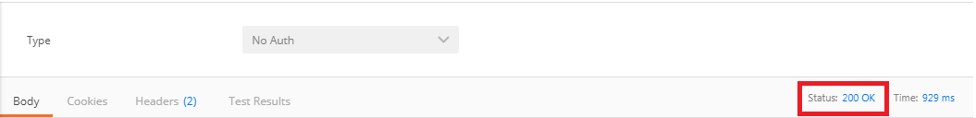
Status: 200 OK denotes that record has been deleted successfully.
Again send a DELETE request with the same URL http://localhost:8080/jpa/users/1. It returns a message "no entity with id 1 exist".
- {
- "timesatmp": "2017-07-20T12:10:29.988+0000",
- "message": "No class com.javatpoint.rest.webServices.restfulwebservices.user. User entity with id 1 exists! ",
- "details": "uri=/jpa/user/1"
- }
Now we will generate a POST request to create a user.
Step 4: Send a POST request with the URL http://localhost:8080/jpa/users.
Step 5: Click on the Headers tab and make sure that the Content-Type is application/json.
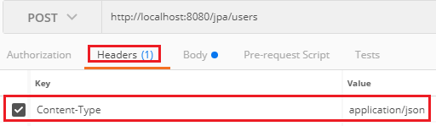
Step 6: Go to the Body tab and enter the name and dob of the user. We have entered the name James.
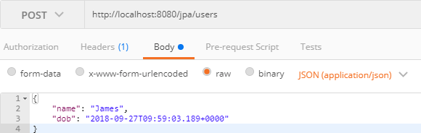
Step 7: Click on the Send button. When we try to create a user, it throws ConstaintViolationException.
It is because hibernate uses a sequence. In the User entity, Id is generated value, so it creates a sequence for us. Hibernate is trying to insert a row with id 1. It conflicts with the data that we already have. To remove this conflict, do the following:
Step 8: Open the data.sql file and change the Ids.
- insert into user values(101, sysdate(), "John");
- insert into user values(102, sysdate(), "Robert");
- insert into user values(104, sysdate(), "Andrew");
- insert into user values(105, sysdate(), "Jack");
Step 9: Again send a POST request. It returns the Status: 201 Created. The status shows that the user is created successfully.
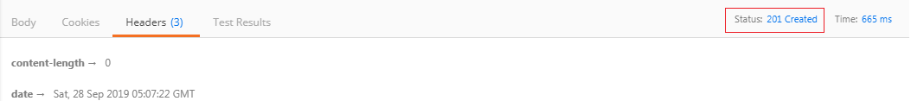

Creating Post Entity and Many to One Relationship with User Entity
In this section, we will create a Post entity that contains many to one relationship with the User entity.
Step 1: Create a class with the name Post.java in the package com.javatpoint.server.main.user.
Step 2: Post.java is an entity, so we need to add @Entity annotation.
Step 3: Add three fields: id, description, and user.
- private Integer id;
- private String description;
- private User user;
Step 4: Generate Getters and Setters.
Step 5: Generate toString().
Remember: Uncheck the user during the generation of toString().
Step 6: A user can do many posts, so add @ManyToOne annotation. The User entity has many to one relationship with the Post entity. The fetch type will not retrieve the details of the user unless we called Post.getUser.
- @ManyToOne(fetch=FetchType.LAZY)
Step 7: Id is a primary key, so we need to add @Id annotation.
Post.java
- package com.javatpoint.server.main.user;
- import javax.persistence.Entity;
- import javax.persistence.FetchType;
- import javax.persistence.GeneratedValue;
- import javax.persistence.Id;
- import javax.persistence.ManyToOne;
- @Entity
- public class Post
- {
- @Id
- @GeneratedValue
- private Integer id;
- private String description;
- //many to one mapping
- @ManyToOne(fetch=FetchType.LAZY)
- private User user;
- public Integer getId()
- {
- return id;
- }
- public void setId(Integer id)
- {
- this.id = id;
- }
- public String getDescription()
- {
- return description;
- }
- public void setDescription(String description)
- {
- description = description;
- }
- public User getUser()
- {
- return user;
- }
- public void setUser(User user)
- {
- this.user = user;
- }
- @Override
- public String toString()
- {
- return String.format("Post [id=%s, description=%s]", id);
- }
- }
We have configured the relationship on the side of Post entity. Now we are required to configure relationship on the side of User entity.
A user can make a list of posts, so the post has one-to-many relationships.
Step 8: Open User.java file and create a list of posts.
- private List<Post> posts
Step 9: Add an annotation @OneToMany with property (mappedBy="user"). It will create a relationship column in the Post entity.
Step 10: Generate Getters and Setters.
User.java
- package com.javatpoint.server.main.user;
- import java.util.Date;
- import java.util.List;
- import javax.persistence.Entity;
- import javax.persistence.GeneratedValue;
- import javax.persistence.Id;
- import javax.persistence.OneToMany;
- import javax.validation.constraints.Past;
- import javax.validation.constraints.Size;
- import io.swagger.annotations.ApiModel;
- import io.swagger.annotations.ApiModelProperty;
- @ApiModel(description="All details about the user")
- @Entity
- public class User
- {
- //Id as a primary key
- @Id
- @GeneratedValue
- private Integer id;
- @Size(min=5, message="Name should have atleast 5 characters")
- @ApiModelProperty(notes="name should have atleast 5 characters")
- private String name;
- @Past
- @ApiModelProperty(notes="Birth date should be in the past")
- private Date dob;
- //default constructor
- @OneToMany(mappedBy="user")
- private List<Post> posts;
- protected User()
- {

- }
- public User(Integer id, String name, Date dob)
- {
- super();
- this.id = id;
- this.name = name;
- this.dob = dob;
- }
- public Integer getId()
- {
- return id;
- }
- public void setId(Integer id)
- {
- this.id = id;
- }
- public String getName()
- {
- return name;
- }
- public void setName(String name)
- {
- this.name = name;
- }
- public Date getDob()
- {
- return dob;
- }
- public void setDob(Date dob)
- {
- this.dob = dob;
- }
- public List<Post> getPosts()
- {
- return posts;
- }
- public void setPosts(List<Post> posts)
- {
- this.posts = posts;
- }
- @Override
- public String toString()
- {
- //return "User [id=" + id + ", name=" + name + ", dob=" + dob + "]";
- return String.format("User [id=%s, name=%s, dob=%s]", id, name, dob);
- }
- }
Step 11: Restart the application.
We can see in the log that there are two tables post and user. The Post table has a link to the User table by a user id. A user can have multiple posts, and all of them have the same user id.
Step 12: Now, open the H2 Console. We can see that are two tables named USER and POST.
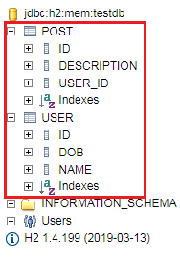
Step 13: Open the data.sql file that we have created earlier and insert the data into POST table. We have inserted the following data:
data.sql
- insert into user values(101, sysdate(), 'John');
- insert into user values(102, sysdate(), 'Robert');
- insert into user values(104, sysdate(), 'Andrew');
- insert into user values(105, sysdate(), 'Jack');
- insert into post values(111, 'first post', 101);
- insert into post values(112, 'second post', 101);
- insert into post values(113, 'third post', 104);
Step 14: Restart the application.
Step 15: Restart the H2 Console and execute the query SELECT *FROM POST;
It shows the data which we have inserted into the data.sql file.
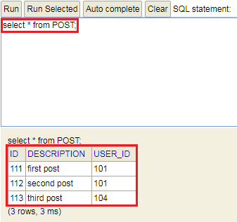

Implementing a GET service to retrieve all Posts of a User
In this section, we will retrieve all the posts of a specific user.
Step 1: Open the UserJPAResource.java file and create a mapping for the URI "/jpa/users/{id}/posts"
- @GetMapping("/jpa/users/{id}/posts")
- public List<Post> retriveAllUsers(@PathVariable int id)
- {
- Optional<User> userOptional= userRepository.findById(id);
- if(!userOptional.isPresent())
- {
- throw new UserNotFoundException("id: "+ id);
- }
- return userOptional.get().getPosts();
- }
Step 2: There is no need to show user detail in the response, so we will add @JsonIgnore annotation just above the User field in Post.java file.
Step 3: Open the Postman and send a GET request with the URI http://localhost:8080/jpa/users/{id}/posts. In our case, we have specified user id 101. It shows all the posts done by user 101.
- [
- {
- "id": 111,
- "description": "first post"
- },
- {
- "id": 112,
- "description": "second post"
- }
- ]
Now, we send a GET request for the user who has not created any post yet. The user 105 has not created any post so we will specify this user id in the URI http://localhost:8080/jpa/users/105/posts.
It shows a pair of empty square brackets. The brackets denote that the user exists, but the user has not created any post.
Again send a GET request for the user who does not exist in the database say 110. It shows the Status: 404 Not Found with the following details:
- {
- "timesatmp": "2019-10-05T05:31:09.407+0000",
- "message": "id-110",
- "details": "uri=/jpa/users/110/posts"
- }

Implementing POST Service to Create a Post for a User
In this section, we will enable post-operation to create a post for the specific user.
Step 1: Open the UserJPAResource.java file and create a PostMapping to create a post.
- @PostMapping("/jpa/users/{id}/posts")
- public ResponseEntity<Object> createUser(@PathVariable int id, @RequestBody Post post)
- {
- Optional<User> userOptional= userRepository.findById(id);
- if(!userOptional.isPresent())
- {
- throw new UserNotFoundException("id: "+ id);
- }
- User user=userOptional.get();
- //map the user to the post
- post.setUser(user);
- //save post to the database
- postRepository.save(post);
- //getting the path of the post and append id of the post to the URI
- URI location=ServletUriComponentsBuilder.fromCurrentRequest().path("/{id}").buildAndExpand(post.getId()).toUri();
- //returns the location of the created post
- return ResponseEntity.created(location).build();
- }
Step 2: Create a post repository.
PostRepository.java
- package com.javatpoint.server.main.user;
- import org.springframework.data.jpa.repository.JpaRepository;
- import org.springframework.stereotype.Repository;
- @Repository
- public interface PostRepository extends JpaRepository<Post, Integer>
- {

- }
Step 3: Open the Postman and send a POST request with the URI http://localhost:8080/jpa/users/102/posts. Under the Body tab, insert the post description.
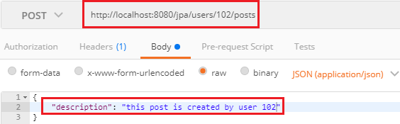
It returns the Status: 201 Created. We can also see this post in the database by executing the query select *from post;

Richardson Maturity Model
Richardson Maturity Model grades API by their RESTful maturity. It is proposed by Leonard Richardson. The Richardson maturity model is a way to grade your API according to the constraints of REST. It breaks down the principal element of the REST approach into four levels (0 to 3).
There are four levels:
- Level 0: The Swamp of POX(RPC CALLS)
- Level 1: Resources
- Level 2: HTTP Verbs
- Level 3: Hypermedia Control(HATEOS) //more restful
For example, a level higher is more RESTful compared to one that is at a lower level. Only when an API reaches level 4, we consider it as a RESTful API.
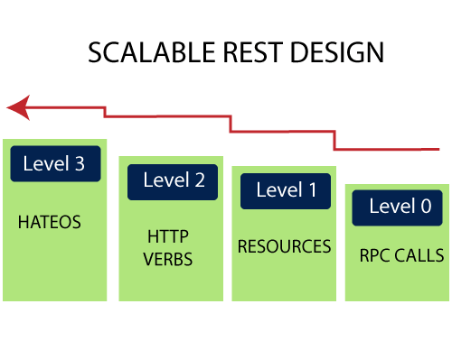

Level 0: The Swamp of POX
Level 0 is also known as POX (Plain Old XML). At level 0, HTTP is used only as a transport protocol that is used as a remote interaction. It does not take the advantages of HTTP like different HTTP methods, and HTTP cache. To get and post the data, we send a request to the same URI, and only the POST method may be used. These APIs use only one URI and one HTTP method called POST. In short, it exposes SOAP web services in the REST style.
For example, there can be many customers for a particular company. For all the different customers, we have only one endpoint. To do any of the operations like get, delete, update, we use the same POST method.
To get the data: http://localhost:8080/customer
To post the data: http://localhost:8080/customer
In the above two URIs, we have used the same URI and method to get and post the customers.

Level 1: Resources
When an API can distinguish between different resources, it might be at level 1. It uses multiple URIs. Where every URI is the entry point to a specific resource. It exposes resources with proper URI. Level 1 tackles complexity by breaking down huge service endpoints into multiple different endpoints. It also uses only one HTTP method POST for retrieving and creating data.
For example, if we want a list of specific products, we go through the URI http://localhost:8080/products. If we want a specific product, we go through the URI http://localhost:8080/products/mobile.
Remember the following points while building a URI:
- Use domain and subdomain to logically group or partition resources.
- Use / to indicate a hierarchical relationship.
- Use , and ; to indicate non-hierarchical relationships.
- Use - and _ to improve the readability.
- Use & to separate parameters.
- Avoid including file extensions.

Level 2: HTTP Verbs
Level 2 indicates that an API must use the protocol properties to deal with scalability and failures. At level 2, correct HTTP verbs are used with each request. It suggests that in order to be truly RESTful, HTTP verbs must be used in API. For each of those requests, the correct HTTP response code is provided.
We don't use a single POST method for all requests. We use the GET method when we request a resource, and use the DELETE method when we want to delete a resource. Also, use the response codes of the application protocol.
For example, to get the customers, we send a request with the URI http://localhost:8080/customers, and the server sends proper response 200 OK.
The following table shows the HTTP verbs and their usage:
Verbs | Safety & Idempotency | Usage
GET | Y/Y | It retrieves the information.
POST | N/N | It is used to perform a variety of actions on the server, such as create a new resource, and update an existing resource, or making a mixture of changes to one or more resources.
DELETE | N/Y | It is used to delete a resource.
PUT | N/Y | It is used to update or replace an existing resource or to create a new resource with a URI specified by the client.
HEAD | Y/Y | It is used to retrieve the same headers as that of GET response but without any body in the response.
OPTIONS | Y/Y | It is used to find the list of HTTP methods supported by any resource or to ping the server.
TRACE | Y/Y | It is used for debugging, which echo's back headers that it has received.

Level 3: Hypermedia Controls
Level 3 is the highest level. It is the combination of level 2 and HATEOAS. It also provides support for HATEOAS. It is helpful in self-documentation.
For example, if we send a GET request for customers, we will get a response for customers in JSON format with self-documenting Hypermedia.
The following figure shows the overview of the model:
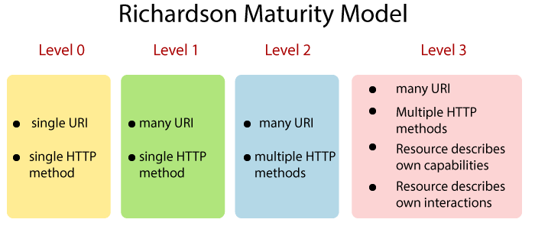

RESTful Web Services Best Practice
In this section, we will evaluate the best practice that must be followed while developing RESTful Web Services.
The first and last best practice is the Consumer First. It means, always think about your consumers. Before naming your resources, think from the perspective of the customers, what do they think about those resources? Will they able to understand these resources?
Consumer First
We must have excellent documentation for our API. Swagger is one of the most popular documentation standard for RESTful API. Make sure that our consumer understands the documentation that we have produced.
The next best practice is to make the best use of HTTP. RESTful web services are based on HTTP. Make the best use of the request methods. Use the right request method (GET, POST, PUT, and DELETE) appropriate for our specific action and ensure that we are sending a proper response status back.
For example, when a RESOURCE NOT FOUND, don't send the SERVER ERROR. When a resource is CREATED, don't send SUCCESS, send CREATED back.
Ensure that there is no secure information in the URI. Think about what you are putting in your URI. Ensure that there is nothing secure that is going in the URIs.
Always use plurals. In the previous examples, we have used /users instead of using /user. Similarly, for accessing a resource, we have used /users/1 not /user/1. It is more readable than using the singular.
When we think about resources, always use nouns for resources. But it is not always possible. There are always exception scenarios. For all these exceptions scenarios, define a consistent approach if we are searching through user use /user/search.
For example, if we put a star on the gists the Github sends the request to the resource of the gists (/gists/{id}) and sends a put request with the star in the URI.

Spring Boot REST Example
The REST application follows the REST architectural approach. We use the REST application for developing and designing networked applications. It generates the HTTP request that performs CRUD operations on the data. Usually, it returns data in JSON or XML format.

Spring Boot REST API Example
In the following example, we are going to create a REST application. In this application, we have created a list of products and return the same list. It returns the data in JSON format.
Let's implement it in RSET application and understand the REST approach by using the following steps.
Step 1: Open the Spring Initializr https://start.spring.io/.
Step 2: Select the Spring Boot version 2.3.0.M2.
Step 3: Provide the Group name. We have provided the Group name com.javatpoint.
Step 4: Provide the Artifact. We have provided the Artifact spring-boot-rest-example.
Step 5: Add the Spring Web dependency.
Step 6: Click on the Generate button. When we click on the Generate button, it wraps all the specifications related to application into a Jar file and downloads it to the local system.
Step 7: Extract the jar file.
Step 8: Copy the folder and paste it in the STS workspace.
Step 9: Import the project.
File -> Import -> Existing Maven Projects -> Next -> Browse -> Select the folder spring- spring-boot-rest-example -> Select Folder -> Finish
It takes time to import the project. When the project imports successfully, we can see it in the Package Explorer section of the IDE.
Step 10: Create a model class in the package com.javatpoint. We have created a model class with the name Product. In this class, do the following:
- Create five variable id, pname, batchno, price, and noofproduct.
- Create a default constructor.
- Generate Constructor using Fields.
Right-click on the file -> Source -> Generate Constructor using Fields -> Select All -> Generate
- Generate Getters and Setters.
Right-click on the file -> Source -> Generate Getters and Setters -> Select All -> Generate
After completing all the steps, the model class looks like the following.
Product.java
- package com.javatpoint;
- public class Product
- {
- private int id;
- private String pname;
- private String batchno;
- private double price;
- private int noofproduct;
- //default constructor
- public Product()
- {

- }
- //constructor using fields
- public Product(int id, String pname, String batchno, double price, int noofproduct)
- {
- super();
- this.id = id;
- this.pname = pname;
- this.batchno = batchno;
- this.price = price;
- this.noofproduct = noofproduct;
- }
- //getters and setters
- public int getId()
- {
- return id;
- }
- public void setId(int id)
- {
- this.id = id;
- }
- public String getPname()
- {
- return pname;
- }
- public void setPname(String pname)
- {
- this.pname = pname;
- }
- public String getBatchno()
- {
- return batchno;
- }
- public void setBatchno(String batchno)
- {
- this.batchno = batchno;
- }
- public double getPrice()
- {
- return price;
- }
- public void setPrice(double price)
- {
- this.price = price;
- }
- public int getNoofproduct()
- {
- return noofproduct;
- }
- public void setNoofproduct(int noofproduct)
- {
- this.noofproduct = noofproduct;
- }
- }
Now, we need to create a controller.
Step 11: In the com.javatpoint package, create a Controller. We have created a controller with the name ProductController.
- Annotate the class with the annotation @RestController.
- We have autowired the IProductService interface. We will create it in the next step.
- We have created a mapping /product by using the annotation @GetMapping.
- We have mapped a method getProduct() to the /product. The method returns a list of products.
ProductController.java
- package com.javatpoint;
- import java.util.List;
- import org.springframework.beans.factory.annotation.Autowired;
- import org.springframework.web.bind.annotation.GetMapping;
- import org.springframework.web.bind.annotation.RestController;
- @RestController
- public class ProductController
- {
- @Autowired
- private IProductService productService;
- //mapping the getProduct() method to /product
- @GetMapping(value = "/product")
- public List<Product> getProduct()
- {
- //finds all the products
- List<Product> products = productService.findAll();
- //returns the product list
- return products;
- }
- }
Step 12: Create an interface in the package com.javatpoint with the name IProductService and define the findAll() method that returns a List of products.
IProductService.java
- package com.javatpoint;
- import java.util.List;
- public interface IProductService
- {
- List<Product> findAll();
- }
Step 13: Create a Service class. We have created a service class in the package com.javatpoint with the name ProductService.
- Annotate the class with the annotation @Service and implements the IProductService interface.
- In this class, override the findAll() method by using the annotation @Override. The findAll() method of the ProductService class overrides the findAll() method of the IProductService interface.
- Create an object of ArrayList.
- Add the products in the ArrayList.
- Return the list of the products.
ProductService.java
- package com.javatpoint;
- import java.util.ArrayList;
- import java.util.List;
- import org.springframework.stereotype.Service;
- @Service
- public class ProductService implements IProductService
- {
- @Override
- public List<Product> findAll()
- {
- //creating an object of ArrayList
- ArrayList<Product> products = new ArrayList<Product>();
- //adding products to the List
- products.add(new Product(100, "Mobile", "CLK98123", 9000.00, 6));
- products.add(new Product(101, "Smart TV", "LGST09167", 60000.00, 3));
- products.add(new Product(102, "Washing Machine", "38753BK9", 9000.00, 7));
- products.add(new Product(103, "Laptop", "LHP29OCP", 24000.00, 1));
- products.add(new Product(104, "Air Conditioner", "ACLG66721", 30000.00, 5));
- products.add(new Product(105, "Refrigerator ", "12WP9087", 10000.00, 4));
- //returns a list of product
- return products;
- }
- }
Step 14: In the static folder (src/main/resources/static), create an HTML file. We have created an HTML file with the name index. In this file we have created a link of Get all Products.
index.html
- <!DOCTYPE html>
- <html>
- <head>
- <title>Home page</title>
- <meta charset="UTF-8">
- <meta name="viewport" content="width=device-width, initial-scale=1.0">
- </head>
- <body>
- <p>
- <a href="product">Get all Products</a>
- </p>
- </body>
- </html>
Now we have created all the files and folders. After creating all the files, the project directory looks like the fooling:
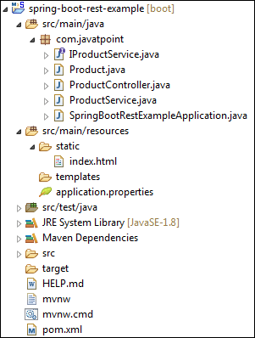
Let's run the application.
Step 15: Open the SpringBootRestExampleApplication.java file and run it as Java Application. By default, it runs on port 8080.
SpringBootRestExampleApplication.java
- package com.javatpoint;
- import org.springframework.boot.SpringApplication;
- import org.springframework.boot.autoconfigure.SpringBootApplication;
- @SpringBootApplication
- public class SpringBootRestExampleApplication
- {
- public static void main(String[] args)
- {
- SpringApplication.run(SpringBootRestExampleApplication.class, args);
- }
- }
When the application runs successfully, it shows the message, as shown below
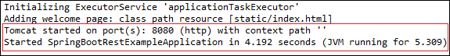
Step 16: Open the browser and invoke the URL http://localhost:8080/index.html. It shows the link of Get all Products, as shown in the following image.
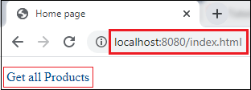
Click on the link Get all Products. It returns a list of products in JSON format and the URL change to http://localhost:8080/product.
